ASME NEWS & VIEWS  Published monthly except July & August  A.S.M.E. Florida West Coast Section  1515 Ruth Road  Dunedin, FL 34698 | 
September 2002, Volume 7 Issue 1

Indy Racing and the Effect of Aerodynamics on the Car
September 18, 2002

Mr. Arthur W. Ebeling holds a B.S. from Rose Hulman Institute of Technology and has very broad experience in chemical, steel, foundry, and special metals industries. Holder of several patent rights in the controlled pressure pouring area, he is an ASME Fellow and has served in various capacities in a number of ASME units. His last position was Midwest Director, a position he held for 18 years. His special interest is Indy racing cars.

Mr. Arthur W. Ebeling has compiled information on Indy cars for nearly a half-century, covering development and changes to the sport. Currently retired and ASME Midwest Director Emeritus, Mr. Ebeling has been involved at various levels in racing from professional to student competitions.

Highlights of the program include:

- Marmon Wasp roadster, front wheel drive, side winder, rear engine mount, gas turbine, wings front and back, ground effects, pods on each side of the cockpit, tire changes, frontal area reduction, engine changes, turbo-charging, non turbo-charging, and safety concerns.
- The suspension problems relating to set-up as well as changes in driving patterns.
- Wind tunnel testing as related to wings and tires.

Date: | Wednesday, September 18, 2002
Location: | Holiday Inn Select, 3535 Ulmerton Road, Clearwater, FL (see map)
Time: | Social Hour from 6:00 – 7:00 p.m. Dinner begins at 7:00 p.m. followed by the program
Menu: | London Broil ... Marinated Steak, topped with Bordelaise Sauce, Crisp Garden Salad, Oven Browned New Potatoes, Fresh Vegetables, Rolls & Butter, Dessert. Choice of Iced Tea, Regular, or Decaf Coffee
Price: | Members & Guests $18.00 per person, includes tax & gratuity. ASME Student Members: $ 9.00
NOTE! | THIS MEETING IS LIMITED TO THE FIRST 40 RESERVATIONS
Reservations: | Reservations and cancellations are required by noon on Monday, Sept. 16, 2002. To make reservations, call Helen Prince at 727-734-5546. Make your checks payable to ASME-FWCS and mail to Helen Prince, 1515 Ruth Road, Dunedin, FL 34698-4416. All ASME dinner meetings are open to the general public. Please call BEFORE sending your check. If you make a reservation & do not cancel by noon, Sept. 16th, you will be billed.

Chairman’s Message
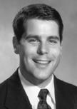 | There are many important facets to ASME. Anyone who disagrees with this statement need only visit the ASME website (www.asme.org) to get a feel for the range of what ASME accomplishes, for members and non-members alike, on a worldwide basis. The organization’s accomplishments include being one of the largest publishers of technical journals, hosting dozens of technical conferences each year, and setting a wide variety of critical industry standards. Yet, arguably, the most important work of the organization takes place here at the local level by members such as yourself. This work includes
planning speakers and tours for the program year, establishing professional development courses and holding a design contest for area high school students. Your local executive board encourages you to participate in these events and help keep the Florida West Coast Section one of the most active sections in the Southeastern Region.
This year’s events begin with speaker Arthur Ebeling, who will discuss aerodynamics as it applies to Indy car racing. Details on this event, which will take place at the Clearwater Holiday Inn Select, are included with this newsletter; we encourage you to make reservations early as interest is high and space is limited. Yet another important event in this program year is the student design contest that will take place in the beginning of March at Tyrone Square Mall. During the event, bay area students are given a limited number of supplies with which they must carry out an assigned task. Similar to the popular show “Junk Yard Wars,” the innovations created by the students are always fascinating to watch. Encouraging the study of engineering is one of the most important jobs we have as ASME members, so I urge each of you to get involved with this event. Those wishing to volunteer can contact board member Adam Jenkins at (727) 345-7085. Finally, the highlight of this year will be the Third Annual Engineer’s Week Banquet to be held on February 21 at the A La Carte Pavilion in Tampa. Through the efforts of Al Kurzenhauser and others, this event has grown rapidly since its inception and is now the premiere engineering event of the area, attracting members of different engineering organizations throughout Florida’s west coast. Information on both the banquet and design contest will be included in future newsletters.
In conclusion, I would like to thank this year’s officers, they include: Vice-Chair Carl Riddlemoser; Vice-Chair of Programs Stephen Elting; Secretary Bob Visbisky; and Treasurer Bob Andrew. I’d also like to thank Aimee Taylor for volunteering to be our Newsletter Editor, Noel McCormick for leading the way in our professional development efforts and Adam Jenkins for overseeing the student design contest. These people have already put in a great deal of time and effort and they should be congratulated. Similarly, I’d like to thank all the outgoing officers -- including our outgoing Treasurer, and new Member Interests Coordinator, Tim Hunt-- for their hard work over the past year. A special note of thanks also goes to our outgoing Chairman, and new Director, Neville G. Brass for efforts that helped make the past two years so successful. Finally, no list of thanks would be complete without mentioning Helen and Clarence Prince who are truly the lifeblood of our section.
I look forward to seeing each of you out at an ASME-FWCS event this year.
Very truly yours,
Michael J. Colitz, III
Chairman
ASME-FWCS

Executive Board Meetings 2002 – 2003  Contact Bob Andrew for meeting locations and times. |  | Upcoming Dinner Meetings 2002 - 2003
September 11 | February 12 |  | WATCH FOR IT! A convenient business card listing of ASME Dinner Meetings is included in this newsletter!
October 16 | March 12
November 20 | April 16
December 18 | May 21
January 22 | June 11

2002 – 2003 Professional Development Tentative Schedule
For more information, contact Noel McCormick
(727) 735-9633 or noel@mccormicktech.com
Date | Activity |  | Instructor | Location
October (TBD) |  | Electronics Cooling Seminar | Daniel Jones, Raytheon | TECO ETRC, Tampa
October 28-30 (M – W) |  | Shock & Vibration Seminar. | Wayne Tustin, ERI | Raytheon, St. Pete
 |  | For additional information, and to sign up, visit:
 |  | http://www.equipment-reliability.com/course4.htm
November |  | Finance for Engineers | TBD | TECO ETRC, Tampa
January |  | Computational Fluids Seminar | Vendor Sponsor (TBD) | USF, Tampa
 |  | PE Review (TBD)
February |  | Project Management | TBD | TECO ETRC, Tampa
 |  | PE Review (TBD)
March |  | GD&T Seminar | Don Patz | TECO ETRC, Tampa
 |  | PE Review (TBD)
April |  | FEA Tools & Techniques | TBD | USF, Tampa
May |  | Communications Skills Seminar | TBD | TECO ETRC, Tampa

June’s Meeting: Elevated Light Rail Transportation for the 21st Century
We thank Mr. Wilfred Sergeant, PE & Vice President of Sky Train Corporation, and Mr. Karl Guenther, Chairman and CEO of Sky Rail UK LTD, for their presentation on how Overhead Light-Rail Systems are designed and how they can alleviate urban gridlock in the 21st century. One of the most interesting aspects of the Sky Train system is its ability to navigate a 2 degree curve at 1.67 times the speed of an ordinary rail without passengers ever feeling any unbalancing acceleration. The presentation also showed how the Sky Train design offers wide-door, level walkways for the handicapped and an overhead track with a small (8 ft) footprint to eliminate ground shadows. Overall, the presentation served to strengthen support for the 2000 amendment to the Florida constitution, which requires a high-speed rail system between Tampa, Orlando, and Miami, by illustrating the economic, social, and environmental benefits of such a transportation system.
June’s Meeting: Honors & Awards
After the excellent presentation by Mr. Sergeant and Mr. Guenther, Neville Brass presented Certificates of Appreciation to the following Officers & Executive Committee Members: Michael Colitz, III, Carl Riddlemoser, Tim Hunt, Robert Andrew, William Adkins, Al Kurzenhauser, John Mulvihill, Robert Pennington, Robert Visbisky, Noel McCormick, Karen Vallar, Dr. Ronald Mann, Dr. Gerry Miller, Helen Prince, Clarence Prince, Robert Pennington, Bill Tarver, Chester Ugan, James Windgassen, Richard Fraze, & Stephen Elting. A plaque was also presented to Neville Brass for his leadership as chair. Robert Andrew also received the ASME Dedicated Service Award for his contributions above the call of duty to our section.
Thanks to all of these dedicated members for their service to our section!

Member Interest Corner
By: Tim Hunt
For Fun! | Armani's, the only Four Star restaurant in Tampa, is nestled atop the Hyatt Regency Westshore with breathtaking views overlooking Old Tampa Bay and the city skyline.  "Wednesday Wine Tastings" continue on September 25th featuring Cakebread Sauvignon Blanc, Joseph Phelps Merlot, Morgan Reserve Chardonnay, and Mariah Zinfandel. All tastings are from 5:30pm-6:30pm. $10.00 per person, per event. Stay for dinner and with each entree purchased your Tasting Fee will be waived. (Men are required to wear sports jackets.)
On your next visit, please bring the coupon for 20% Discount Off Your Total Food Bill. To print your coupon, please visit the following link:
http://epi.s4m0.com/cp1.p?m=2504&r=Y95D4PACI3R1MWQ2J72W&cid=21885&c=21253&p=8378 See printed coupon for details.
6200 Courtney Campbell Cswy., Tampa, FL 33607
Please call 813.207.6800 for reservations.
Just a reminder! | Under 471.0195 of Chapter 471, F.S. for those with their Florida PE - “Effective January 1, 2000, all licensees participating in the design of engineering works or systems in connection with buildings, structures, or facilities and systems covered by the Florida Building Code shall take continuing education courses….on any portion of the Florida Building Code applicable to the licensee’s area of practice or has passed the appropriate equivalency test of the Building Code Training Program…”
Opportunity! | Anyone who has experience in different techniques of gas separation, with an emphasis on leading edge technologies; and who would like to make a buck or two in consulting income or sell equipment, please Email - rhunts@compuserve.com

ELECTRONIC AGE
If you would like to receive our newsletter via E-mail, please send your address to andrewr@asme.org and put newsletter in the subject line. All addresses will be kept confidential. For the latest information on ASME events, check out the Florida West Coast Section web page. http://www.bobandrew.com/asme We have links to many important and interesting sites for jobs, codes and standards, etc.

Keep Your Address Information
Up-to-Date!
Did you know that newsletters with incorrect addresses cause delays, cost extra postage for your Section, and extra work for volunteers, who must correct addresses and re-mail newsletters? To update your contact information please call Helen Prince at 727-734-5546.

Voices of Innovation
A Daily Radio Series That Celebrates the World of Engineering
Have a great story about a product you invented, the process you created or the work that you do? Want to help educate the public about the value of engineering? Voices of Innovation is a new public radio program being launched by the American Association of Engineering Societies, with generous support from ASME. It will feature the voices of engineering in two-minute programs that explore and celebrate the world of engineering. If you or someone you know has an engineering story to tell, submit a story idea form, which is available at www.voicesofinnovation.com.

Directions to Holiday Inn Select, Clearwater, FL | 2002 ASME INTERNATIONAL MECHANICAL ENGINEERING CONGRESS & EXPOSITION
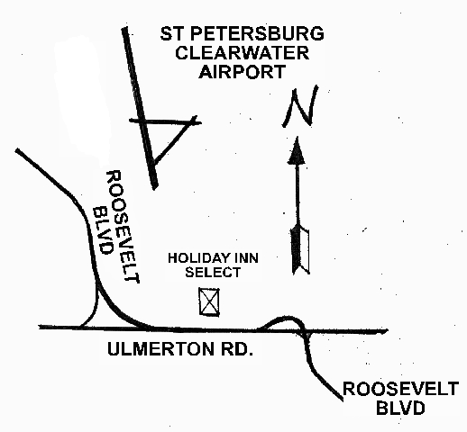 | Nov. 17-22, 2002  New Orleans, Louisiana    Mark Your Calendar,  Bookmark www.asme.org/conf/congress02  Search the program database in the coming  months for sessions, events and papers that best meet your needs.

We thank these sponsors for supporting engineering educational activities with High School and University of South Florida Students:

BE ALL YOU CAN BE!
Be a part of a winning team
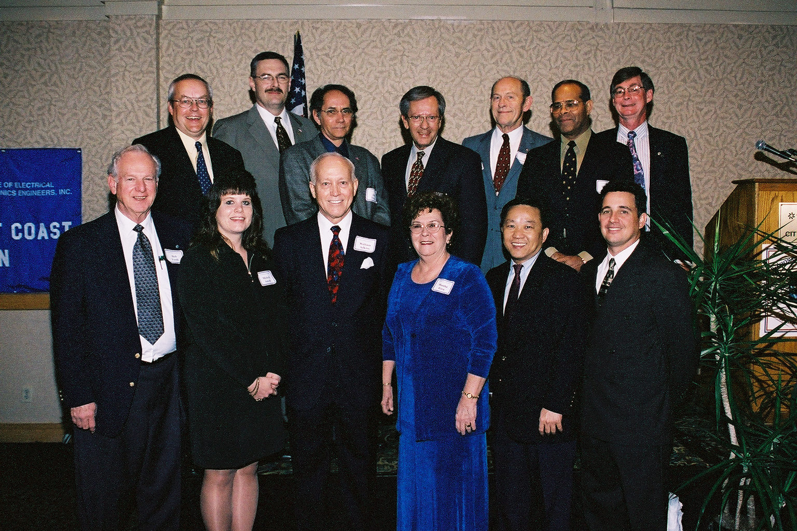
Above are the members of five engineering and technical Societies that planned and executed the most successful Celebrate Engineering 2002 Banquet and Event. Don't they look good? Photographed at the end of the evening, they show pride and satisfaction for bringing to Tampa Bay the most successful Engineer's Week Banquet -- on 2/23/02!

As the event becomes embellished with new features, we are seeking more DEPs* who want to enhance their production planning skills, presence and charm. Those who willingly yearn for fun with the pros in the photo. And, continue to build a stronger Alliance of engineering professionals on the Florida West
Coast! The next CELEBRATE ENGINEERING BANQUET WILL BE at the A La Carte-Engineering Pavilion (Formerly Egypt Temple) on Friday, 2/21/03.
* Dynamic Engineering Pros

Contact Al Kurzenhauser (813-251-6403 or e: kurzenhauser@aol.com) and BE ALL YOU CAN BE!

FLORIDA WEST COAST SECTION OFFICERS FOR 2002-2003
CHAIR | VICE CHAIR | VICE CHAIR – PROGRAMS | TREASURER | SECRETARY
Michael Colitz, III  Holland & Knight LLP  400 N. Ashley Drive.  Tampa, FL 33602  (813) 227-6598  Fax: (813) 229-0134 | Carl Riddlemoser  ATC Assoc., Inc.  5801 Benjamin CTR Dr.  Suite 101, Tampa 33634  (813) 932-8960 ext. 245 | Stephen Elting  ABC Packaging Co.  811 Live Oak Dr.  Tarpon Springs, FL 34689-4199  (727) 937-5144 | Robert W. Andrew  Hudson Pump & Equipment  3524 Craftsman Blvd.  Lakeland, FL 33803  (863) 665-7867 | Robert F. Visbisky, PE  (813) 968-9382
FLORIDA WEST COAST SECTION EXECUTIVE BOARD MEMBERS FOR 2002-2003
William P. Adkins, PE  (727) 539-4702 | Al Kurzenhauser  (813) 251-6403 | John Mulvihill  (813) 749-1134 | Dr. Robert Pennington, II  (727) 345-6885 | Aimee Taylor  (941) 756-2594
Noel McCormick  (727) 735-9633 | Dr. Ronald L. Mann  (727) 938-1645 | Helen Prince  (727) 734-5546 | Bill Tarver  (727) 539-4307 | Richard O. Fraze  (727) 522-6759
Paul Stevenson  (727) 735-9633 | Dr. R. Gerry Miller  (727) 397-6807 | Clarence Prince, PE  (727) 734-5546 | Chester J. Ugan  (727) 527-8191
Adam D. Mainzer  (813) 221-1222 | Tim Hunt, PE  (727) 734-0026 | Adam Jenkins  (727) 345-7085 | Neville G.P. Brass  (727) 397-2737

