September 2000, Volume 5 Issue 1

Tour of U.S. Coast Guard Station Clearwater, C-130s and HH-60 Jay Hawk Helicopters

Wednesday September 13, 2000

The Clearwater Air Station is the Coast Guard’s largest air station. Its operations have been at the heart of significant events in both Florida and the Caribbean for many years. It provided crucial support during the Cuban boatlift, as well as the rescue mission in Grenada. The station also played a key role in operation Wagon Wheel, an international drug interdiction effort. One of the most noteworthy missions of the Air Station was the support it provided during the 1986 Challenger explosion. The Air Station provides support through the use of C-130 and HH-60J Jayhawk helicopters. The Air Station’s past and current activities support its motto of “ANYTIME, ANYWHERE.”

The C-130 “Hercules” performs numerous missions in support of Search and Rescue, Law Enforcement, Marine Environmental Protection, and logistics. The aircraft is an ideal platform for long range search and rescue, with over 14 hours of airborne endurance and large scanner windows built into the airframe side. Originally designed for DOD missions of carrying large cargo loads into short, rough landing strips, the C-130 demonstrates this ability to perfection for the Coast Guard's required support of missions in isolated areas. Clearwater C-130s have deployed to many of the contiguous 48 states, Alaska, Hawaii, the Caribbean, Central and South America, Europe, and many other parts of the world.

The 12 state-of-the-art Sikorsky HH-60J “Jayhawk” helicopters assigned to the air station have a long-range capability of 600 nautical miles to support Coast Guard ships on law enforcement patrols, deliver dewatering pumps to sinking vessels, evacuate injured crew members from vessels far at sea, and many other missions. Air Station Clearwater helicopter aircrews fly an average of over 400 search and rescue cases each year along the coasts of Florida, the Bahamas, and beyond.

When: September 13th , 2000--Social from 6 to 7PM, Dinner starts at 7PM, followed by 45 minute tour of the Coast Guard Station.

Where: Clearwater Air Station and Holiday Inn Select (See map on back page, meeting to start at the Holiday Inn Select)

Dinner: Honey Grilled Chicken Rice, Vegetables and Dessert or
Sliced Roast Beef, Mashed Potatoes, Vegetables and Desert, IceTea /Coffee
Price: Members, non Members and Guests $14.00
ASME Student Members $7.00

Clearwater Air Station Tour Continued

Reservations and cancellations are required by Noon September 11th. To make reservations, call or write John Mulvihill-- 16305 Colwood Drive Odessa, Florida 33556 (813) 855-4612 (Work), (813) 920-6284 (Home), mulvihillj@asme.org. Paying in advance by check would be appreciated. All ASME dinner meetings are open to the general public.

Chairman’s Message

As we lead off into the new millenium, it is indeed an honor and privilege to serve you as chairman for the 2000 & 2001 session supported by a very informed and visionary executive committee-- Tim Hunt, Karen Vallar, Mike Colitz, III, Bob Andrew, Carl Riddlemoser, Dr. Mann, and Bob Pennington.
I would like to thank the past chairman Bob Andrew for the super job he did for the past two terms and I am deeply gratified to him and his executive committee for all the dedication and effort they put in to making the 1999-2000 session so eventful.
I would like to start by making an appeal to the members by encouraging you to come out and support us in larger numbers. We have a membership of some 800 members, but only 40-50 put in an appearance at our monthly meetings. We need to make ourselves more visible. If we are to thrive as a leading engineering professional society-- we should not be members in name only.
Our executive committee works very hard indeed to ensure we put together the most up to date technical topics, top notch speakers and interesting plant tours for your benefit. Please do not disappoint them-- we need your support and presence.
Let me conclude by thanking our senior executive committee members- Al Kurzenhauser, Bill Adkins, John Mulvihill, Bob Visbisky, and Helen and Clarence Prince for their tireless effort and dedication to the Florida West Coast Section. We could all learn a valuable lesson from each one of them. ASME monthly get togethers are a way of staying in sync with the technology of tomorrow.
Neville G. Brass
Chairman

Your Help Needed
We are currently planning our meeting schedule for the upcoming 2000/ 2001-program year. If you would like to showcase your company with a tour, or you have a presentation that you feel would be interesting to our membership, please contact a board member or myself with the details.
Robert Andrew – Program Vice-Chair (941) 665-7867Work (941) 666-5649 Fax
andrewr@asme.org E-mail.

Environmental Management
*Regulatory Reports/Permits *Pollution Prevention
*EMS Programs *Recycling
*ISO *Hazardous Waste
Karen Vallar
Ph. 727-595-6366 Fax 810-885-6289
vallark@asme.org

Upcoming Dates to Remember
Oct 10th -Industry Reception- Venue T.B.A. 6:00-6:30
Oct 11th – Orthopedic Engineering (Speaker – Karen Warden), Clearwater Radisson Bay Harbor
Oct 14th – Tampa Electric (Saturday Tour), Tampa;
Nov 8th –Peerless Fedco in Pasco;
Dec 7th –Social at MacDill Officers Club
Jan 10th – Tampa Armature (Tour) South Tampa
Feb 16th – Engineers Week / Banquet
March 24 - Golf Tourny- Seminole C.C.
March 21st – Student Papers, USF
April 11th – Sun Hydraulics (Tour), Sarasota;
May 9th – Publix Bakery/Dairy (Tour), Lakeland;
June 13th – Honors & Awards (Speaker: Bio-med topic), Clearwater Radisson Bay Harbor

13th Annual Student Design Contest
The 13th annual student design contest is currently being planned and volunteers are needed. This year’s contest will take place on February 10, 2000 at 10AM in the Tyrone Square Mall. Approximately 150 students from both public and private schools participate on teams building mechanisms which they race on a time or distance type course. It is always quite competitive and lots of fun. The contest is designed to promote an enhanced understanding and appreciation of science, and the practical application of engineering principals. Hopefully, the experience will encourage students to follow a path of education to future jobs as scientists and engineers.
Volunteers are needed to help run the contest as well as visit local High Schools to encourage student participation. If you are interested, please contact either Stephen D. Elting (813-961-4546) or Tim Hunt (727-734-0026).

We thank these sponsors for supporting engineering educational activities with High School and University of South Florida Students:

ELECTRONIC AGE

If you would like to receive our newsletter via E-mail, please send your address to andrewr@asme.org and put newsletter in the subject line. All addresses will be kept confidential. For the latest information on ASME events, check out the Florida West Coast Section web page. http://www.bobandrew.com/asme We have links to many important and interesting sites for jobs, codes and standards, etc.

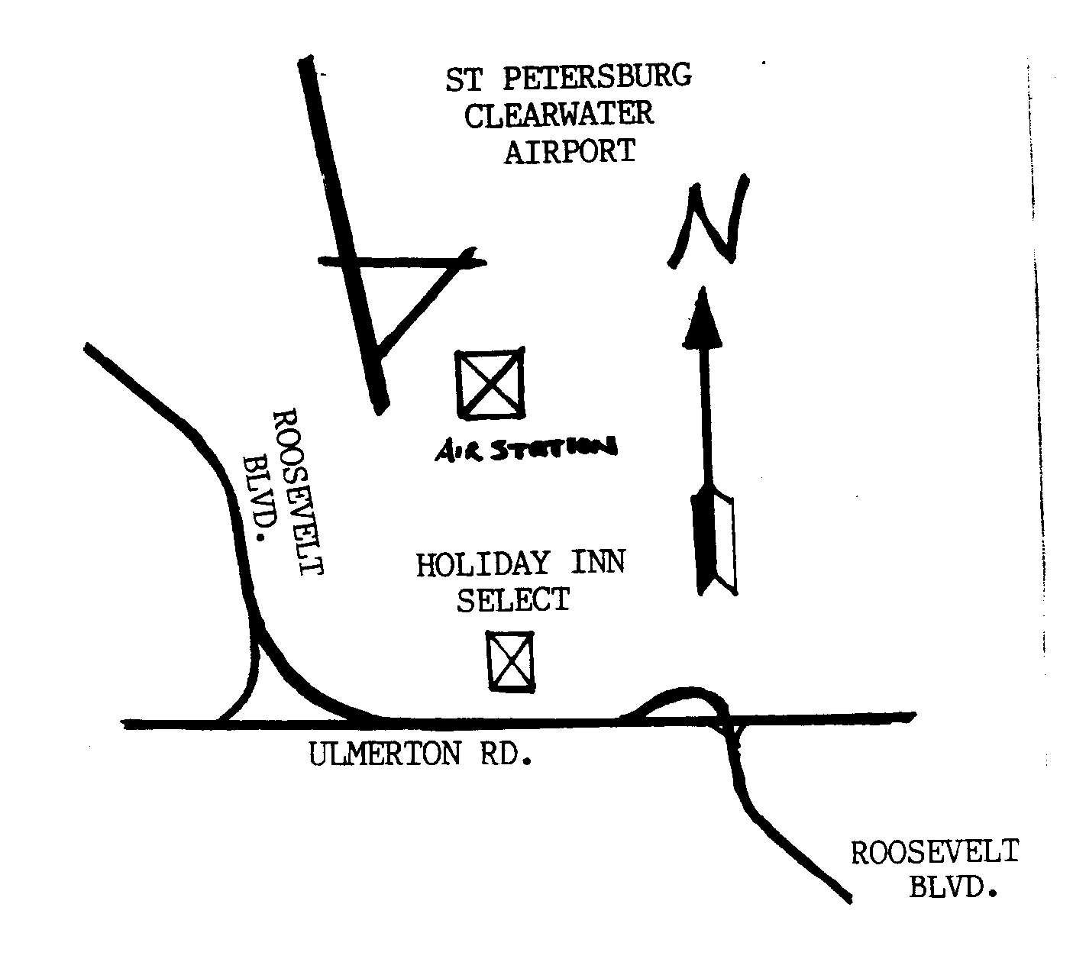

FLORIDA WEST COAST SECTION OFFICERS FOR 2000-2001
CHAIR  Neville G. P. Brass  Lazzara Yachts  5250 W. Tyson Av.  Tampa, FL 33611  813-839-0090  fax 813-831-5442 | VICE CHAIR  Tim Hunt, P.E.  Rhunts Engineering  505 S. Paula Dr.  Dunedin, FL 34695  727-734-0026 | VICECHAIR-PROGRAMS  Robert W. Andrew  Hudson Pump & Equipment  3524 Craftsman Blvd.  Lakeland, FL 303-7307  863-665-7867 |  | TREASURER  Karen Vallar  12800-7852 Vonn Rd.  Largo, FL 33774  727-595-6366 |  | SECRETARY  Michael J. Colitz, III  Holland & Knight  400 N. Ashley Drive.  Tampa, FL 33602  813-227-8500  Newsletter Fax  813 229-0134
FLORIDA WEST COAST SECTION EXECUTIVE BOARD MEMBERS FOR 2000-2001
William P. Adkins PE  727-539-4702  Gene Allen  727-588-0147  Katharine Speltz  813-269-9319 | Al Kurzenhauser  813-251-6403  Dr. Ronald L. Mann  727-938-1645  Dr R. Gerry Miller  727-397-6807 |  | John Mulvihill  813-855-4612  David L. Mustain  727-724-6624  Helen Prince  727-734-5546  Clarence Prince PE  727-734-5546 |  | Robert Pennington  813-974-8284  Carl Riddlemoser  813-932-7332  Bill Tarver  727-539-4307  Chester J. Ugan  727-527-8191 |  | Robert F. Visbisky PE  813-641-5132  James R. Windgassen  727-539-3997  Richard O. Fraze  727-522-6759  Stephen D. Elting  813-831-7286

