ASME NEWS & VIEWS  Published monthly except July & August  A.S.M.E. Florida West Coast Section  1515 Ruth Road  Dunedin, FL 34698 | 
September 2003, Volume 8 Issue 1

 |  | AND | 

Jointly Present

Tour of the Tampa Bay Water Desalination Plant
Apollo Beach, FL
Join the FWCS’s of ASME and IEEE as we tour the nations largest seawater desalination plant right here in Apollo Beach, Florida. You’ve heard about it in the news and read about it in the paper. Now it’s time to see first hand how this facility overcame its critics to become one of 13,600 similar facilities in the world producing over 6.8 billion gallons of drinking water daily. This particular facility is publicly owned by Tampa Bay Water and privately operated by Covanta. It will ultimately provide 25 million gallons per day, or roughly 10%, of the 250 million gallons of potable water used by the Tampa Bay area every day.
The facility plant manager, Ms. Lynn Stevens, will be our tour guide for this exciting start to the new program year. She’ll explain the process behind reverse osmosis, and dispel many of the myths associated with this method of creating drinking water. You won’t want to miss this “behind the scenes” look at our most precious commodity: water!
Your paid attendance will also include dinner after the tour at the Alpha Restaurant, a local favorite for pizza, pasta and prime rib. Nick and his crew have promised us the best Apollo Beach has to offer, so don’t miss out!
Date: | Wednesday, September 10, 2003
Tour Location: | Tampa Bay Water Desalination Plant (see attached map)  13041 Wyandotte Road, Apollo Beach, FL 33534
Time: | First tour leaves at 6:00 pm, with additional tours every 30 minutes as necessary
Dinner Location: | Alpha Restaurant  1312 Apollo Beach Blvd., Apollo Beach, FL
Menu: | Your choice of Chicken Parmesan w/Spaghetti, Stuffed Shells, or Lasagna. Each meal comes with your choice of coffee, tea, or soft drink and cheesecake for desert. There will also be a cash bar.
Price: | Members and guests $15.00 per person, includes tax and gratuity. ASME Student Members $8.00
Reservations and cancellations are required by noon on Monday, Sept 8, 2003. All attendees must be U.S. citizens, or have a valid passport. Parking is limited, so please carpool if possible. To make reservations, call Helen Prince at 727-734-5546. Make your checks payable to ASME-FWCS and mail to Helen Prince, 1515 Ruth Road, Dunedin, FL 34698-4416. All ASME dinner meetings are open to the general public. Please call BEFORE sending your check. If you make a reservation & do not cancel by noon, September 8, you will be billed.

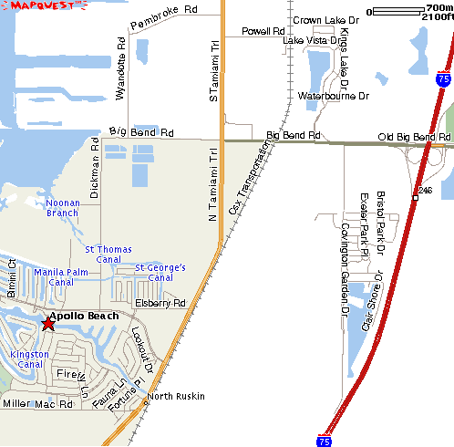
Desal Plant
TECO Plant
Alpha Restaurant
1312 Apollo Beach Blvd.

Directions: Take Interstate 75 south from Tampa, exit Big Bend Road (Exit 246) and head west. You will cross US 41 (Tamiami Trail) and turn right on Wyandotte Road. The Desalination plant will be just past the power plant on the left hand side.

October Meeting Preview: Cross Bayou Water Reclamation Facility

Please join the FWCS of ASME for a behind the scenes tour of the new Pinellas County South Cross Bayou Water Reclamation Facility. We will be given a technical presentation followed by a tour of this brand new state-of-the-art facility. This event is limited to the first 40 paid members, so get your reservations in early.

When: October 8, 2003, 6:00 P.M.
Where: 7401 54th Ave. N., St. Petersburg, FL
Additional details will follow in next month’s newsletter.

JOINT MEETINGS
YES, WE ARE NOT THE ONLY ENGINEERING SOCIETY
ON THE WEST COAST OF FLORIDA!!
Over the past 4 years we have actively worked with IEEE, ASHRAE, AFS, and SOLE with the common medium being the CELEBRATE ENGINEERING BANQUET. This has allowed us to join with 300 persons in our profession at the annual February 2003 Banquet. At the same time, we have held joint meetings, professional courses, etc. with some of these and other professional societies. It is good for each individual engineer and for each professional body to be in close touch with other professionals outside their traditional field. While different types of engineers have different tasks to solve, an understanding of various methods for solving tasks benefits a larger community of engineers.
Unless we join other types of engineers and witness their problem solving methods from time-to-time, we will not benefit from our combined knowledge and skills. Therefore, ASME members benefit by attending joint general meetings and other society EXCOM meetings. Likewise other society members, benefit by attending our meetings.
Thus, our Wednesday, September 10 meeting at the Hillsborough Desalination plant is a Joint meeting with IEEE (FWCS). NOTE: This already was a meeting topic with IEEE this Summer, but it was a Noon meeting. Although the summer meeting had a fine attendance, a majority of members cannot attend such meetings at Mid Day.
We welcome IEEE attendance on the evening of Wednesday, September 10 with us for a tour and technical discussion of the same Desalination plant.
**************
ASME & IEEE have agreed that their respective rules for sign-up and payment apply equally to each member attendee regardless of affiliation. This practice has historical precedent in that most societies have reciprocity on attendee fees for national conferences. The same policy applies to local professional development courses both for personal improvement as well as for meeting state licensing requirements.
If you wanted to attend PE Review Seminars or the PE (Electrical & Computer), these started July 28. Tests will be offered October 25 & 26. If you need to learn more about that offering contact Alan. Keith@pgnmail.com (T- 727-384-7865)
As we progress in joint support and professional development of fellow engineers, please offer me your views on wading deeper into this ocean. (kurzenhauser@aol.com)

One of a Kind Opportunity

The MBA for Engineers & Scientists



Why:

- Combine your technical acumen with a top-ranked (#11) business education
- Fellow classmates are Engineers & Scientists providing deeper perspectives on business solutions relevant to you
- Additional growth & responsibility as a result of broadening education

When:

- Stay in your current job and visit campus just one weekend per month for 27 months (Saturday & Sunday only)
- Next Program starts January 2004

How:

- To apply or ask for a brochure or information session details:

Call 1-877-435-2622 opt. 2

The FWCS will hold an Engineering Exposition in March 2004,
at the USF Sundome, Tampa, FL
Attendees to the Expo will be invited and will include Engineering Design Firms and Manufacturers of Engineered products with special consideration given to employers of mechanical engineers. However, other important design firms and manufacturers in related and other initial fields are wanted as well. After all, engineering is so ubiquitous in everything we own or use and it requires, most often, other disciplines as well as mechanical disciplines. We will not exclude any discipline's products. More information will be available in the next couple of newsletters. Test marketing of the profession in Atlanta, Mississippi, and the West Coast shows the format has promise.
WANTED: ENERGETIC THINKERS TO BRING A NEW FORM OF ENGINEERING EXPO TO THE BAY AREA.

We thank these sponsors for supporting engineering educational activities with
High School and University of South Florida Students:
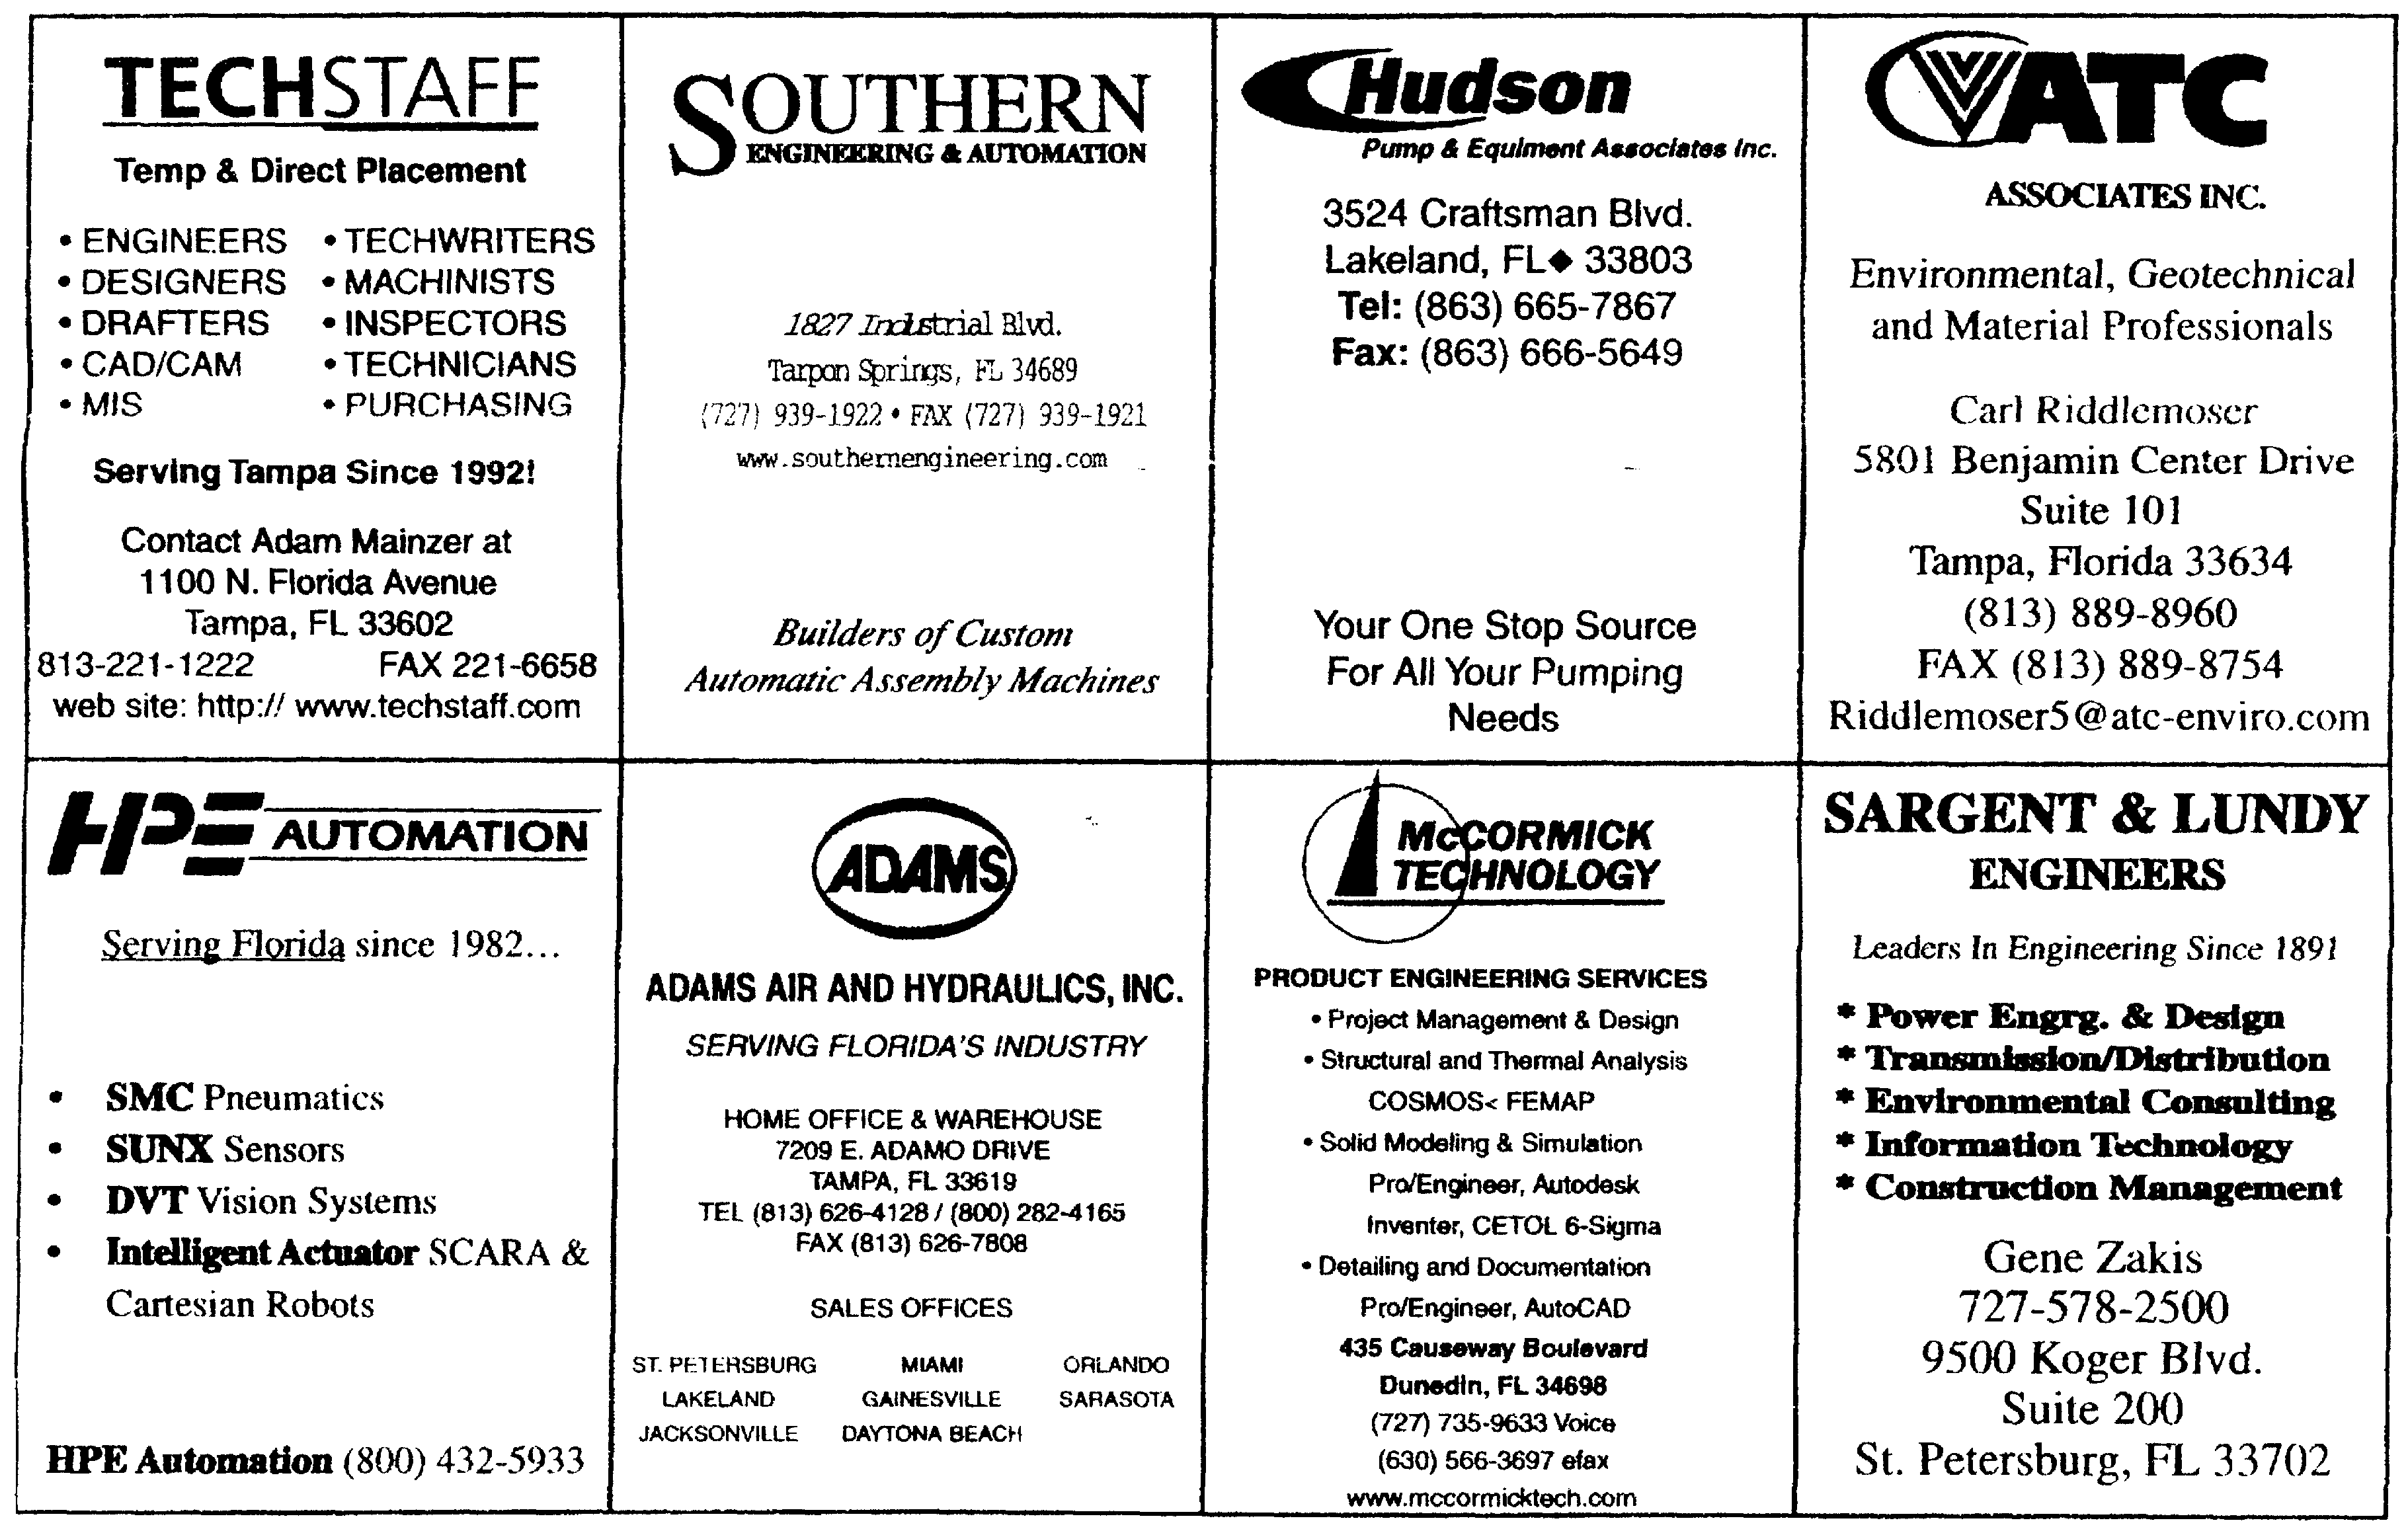

REMEMBER! Keep your address information up-to-date!
Did you know that newsletters with incorrect addresses cause delays, cost extra postage for your Section, and extra work for volunteers, who must correct addresses and re-mail newsletters? To update your contact information please call Helen Prince at 727-734-5546.

Please note that the October Newsletter Deadline is:
Wednesday, September 10th
If you would like to submit a newsletter item to be published in our October newsletter, please call John
Chevalier at (727) 781-2682 by September 10, 2003. We would love to insert your story, event, job opportunity, or job wanted item in the newsletter.

FLORIDA WEST COAST SECTION OFFICERS FOR 2003-2004
CHAIR | VICE CHAIR | VICE CHAIR – PROGRAMS | TREASURER | SECRETARY
Carl Riddlemoser  ATC Assoc., Inc.  5801 Benjamin CTR Dr.  Suite 101, Tampa 33634  (813) 932-8960 ext. 245 | Stephen Elting  ABC Packaging Co.  811 Live Oak Dr.  Tarpon Springs, FL 34689-4199  (813) 966-3667 | Paul D. Stevenson  McCormick Stevenson Corp.  435 Causeway Blvd.  Dunedin, FL 34698  (727) 735-9633 | Robert W. Andrew  Hudson Pump & Equipment  3524 Craftsman Blvd.  Lakeland, FL 33803  (863) 665-7867 | Robert F.  Visbisky, P.E. Retired  (813) 968-9382
FLORIDA WEST COAST SECTION EXECUTIVE BOARD MEMBERS FOR 2003-2004
William P. Adkins, PE  (727) 539-4702 | Al Kurzenhauser  (813) 251-6403 | John Mulvihill  (813) 749-1134 | Aimee Taylor  (727) 669-3780 | Dr. Shuh-Jing “Ben” Ying, PE (813) 286-1904
Noel McCormick  (727) 735-9633 | Dr. Ronald L. Mann  (727) 938-1645 | Helen Prince  (727) 734-5546 | Bill Tarver  (727) 539-4307
Adam D. Mainzer  (813) 221-1222 | Dr. R. Gerry Miller, PE  (727) 397-6807 | Clarence Prince, PE  (727) 734-5546 | Chester J. Ugan  (727) 527-8191
Richard O. Fraze  (727) 522-6759 | Tim Hunt, PE  (727) 734-0026 | John R. Chevalier, PE  (727) 781-2682 | Neville G.P. Brass  (727) 397-2737

Non-profit org.
U.S. Postage
PAID
Tampa, Florida
Permit No. 1610
 | Florida West Coast Section  1515 Ruth Road  Dunedin, FL 34698 | Address Service Requested

