October 2000, Volume 5 Issue 2

Speaker Karen E. Warden
From Case Western Reserve University on
"Orthopaedic Engineering"

"So what is "Orthopaedic Engineering", is it sort of like the bionic man?" Well, no it is not quite that glamorous or futuristic yet, but the advances in our knowledge of musculoskeletal biomechanics, biologic and synthetic biomaterials, and implant design, development and performance certainly serve as one of the foundations of bionics. Consider that in 1988 an estimated 11 million individuals in the US had some form of medical implant and 50% of these were orthopaedic devices. Think of the increases in athlete performance over the past fifty years. Compare the surgical scars left by knee surgery 25 years ago to those of today. All of these examples involve advancement in "Orthopaedic Engineering." This talk describes the history of the discipline, the application of mechanical engineering fundamentals to biomechanics, the types of implants and their materials, the role of the engineer and some of the emerging technology. Samples of orthopaedic implants are exhibited.
Karen E. Warden is a doctoral candidate at Case Western Reserve University specializing in spinal biomechanics. She has been active in the field for the past ten years in academic, industrial, and consulting capacities, has co-authored numerous peer-reviewed publications and received research and achievement awards.

When: October 11th, 2000--Social from 6 to 7PM, Dinner starts at 7PM,

Where: Radisson Bay Harbor Inn (See map on back page)

Dinner: Chicken Monterey, Rice Pilaf, Fresh Vegetables, Garden Salad, Rolls, Coffee, Tea or Ice Tea, Key Lime Pie

Price: Members, non Members and Guests $16.00
ASME Student Members $8.00

Reservations and cancellations are required by Noon October 9th. To make reservations, call Helen Prince at 727-734-5546. Paying in advance by check would be appreciated. Make your check payable to ASME-FWCS and mail to Helen Prince, 1515 Ruth Road, Dunedin, FL 34698. All ASME dinner meetings are open to the general public.

Tour the Tampa Electric Polk Power Station

The Polk Power Station is a state-of-the-art “integrated coal gasification combined-cycle” power plant that produces enough electricity to serve 56,000 homes. The facility began operation in 1996. The plant is a first-of-its-kind combination of two leading technologies. The first technology is called “coal gasification,” which uses coal to create a clean-burning gas. The second technology is called “combined cycle,” which is the most efficient method of producing electricity commercially available today. The integration of these technologies allows Tampa Electric to couple the high efficiency of the combined-cycle design with the low cost of coal for fuel. Come out and witness this revolution in power generation. A box lunch will be provided on site Courtesy of Hudson Pump & Equipment. This tour is being arranged and lead by Plant Manager Mark Hornic.

When: Saturday October 14th 10AM till 12 Noon
Where: Polk Power Station

Directions to Polk Power Station

From Interstate 4 West: Take Interstate 4 West to Exit #23 (U.S. 27 South)
U.S. 27 South to State Road 60 (Lake Wales)
State Road 60 West to State Road 37 (Mulberry)
State Road 37 South to approx. ¼ mile South of Bethlehem Rd.
Turn East (left) and go to Guard Station.

From Interstate 75 South: Take Interstate 75 South to Exit 46B (County Rd. 674, Sun City)
County Rd. 674 East to State Rd. 37 (674 dead ends at State Rd. 37)
Turn North (left) onto State Rd. 37 and go approx.1 1/3 miles to Gate 5
Turn right (East) and go to Guard Station.

From State Rd 37 South: Take State Rd. 37 South approx. 13 miles South of State Rd. 60 (Mulberry)
Approximately ¼ mile South of Bethlehem Rd. to Gate 5 (entrance to Polk Plant Site)
Turn East (left) and go to Guard Station.

Reservations and cancellations are required by Noon October 11th. To make reservations, call Helen Prince at 727-734-5546. Paying in advance by check would be appreciated. Make your check payable to ASME-FWCS and mail to Helen Prince, 1515 Ruth Road, Dunedin, FL 34698. All ASME dinner meetings are open to the general public.

Other Important Dates to Remember

Nov 8th – Peerless Fedco.
Dec 7th- Christmas Social Dinner at Officers Club at McDill.
Jan 10th – Tampa Armature works tour
Feb 16th – Engineers Week / Banquet ASME &IEEE will join forces to do banquet. Ramada on Kennedy
March 24 Golf Tourney- Seminole C.C.
October 10th, Industry Reception 5pm-6pm
March 21st – Student Papers night at U.S.F.
April 11th – Sun Hydraulics (Tour)
May 9th Publix Tour
June 13th – Honors & Awards (Speaker: Bio-med topic), Clearwater Radisson Bay Harbor

FWCS TOURS CLEARWATER COAST GUARD STATION

September’s meeting was a behind the scenes look into the Coast Guard Station at the Clearwater-St. Petersburg Airport. The station plays an important role in search and rescue operations and drug interdiction efforts in the Caribbean and Gulf of Mexico. Members got the opportunity to see Coast Guard equipment up close. This included walking through one of the massive C-130s and the opportunity to sit in the cockpit of an HH-60 Jayhawk helicopter. Our tour guides give FWCS members a unique look into the important role the Coast Guard plays in saving lives. FWCS kindly thanks all those at the Clearwater Coast Guard Station who took the time to showcase their impressive facility.

Industry Reception

FWCS will be hosting an industry reception on October 10th from 5-6 PM at the Crowne Plaza Hotel on Westshore Blvd. The event will showcase ASME's professional development courses to engineering managers in the Tampa Bay area. Currently, ASME offers over 100 technical courses including Codes & Standards, Elevators, Piping, and Welding. If you know of any industry leaders who would be interested in attending this event please call Al Kurzenhauser
813-251-6403.

We thank these sponsors for supporting engineering educational activities with High School and University of South Florida Students:

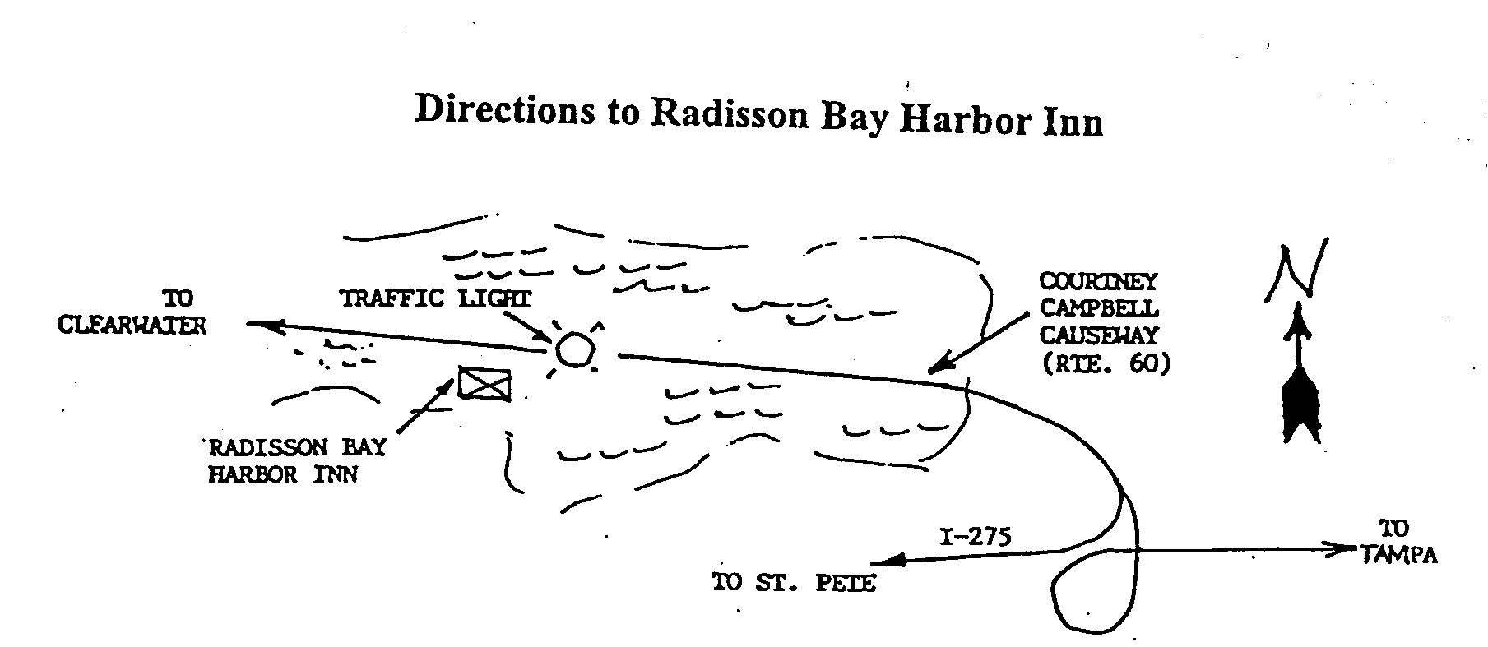

ELECTRONIC AGE

If you would like to receive our newsletter via E-mail, please send your address to andrewr@asme.org and put newsletter in the subject line. All addresses will be kept confidential. For the latest information on ASME events, check out the Florida West Coast Section web page. http://www.bobandrew.com/asme We have links to many important and interesting sites for jobs, codes and standards, etc

FLORIDA WEST COAST SECTION OFFICERS FOR 2000-2001
CHAIR  Neville G. P. Brass  Lazzara Yachts  5250 W. Tyson Av.  Tampa, FL 33611  813-839-0090 | VICE CHAIR  Tim Hunt, P.E.  Rhunts Engineering  505 S. Paula Dr.  Dunedin, FL 34695  727-734-0026 | VICECHAIR-PROGRAMS  Robert W. Andrew  Hudson Pump & Equipment  3524 Craftsman Blvd.  Lakeland, FL 303-7307  863-665-7867 |  | TREASURER  Karen Vallar  12800-7852 Vonn Rd.  Largo, FL 33774  727-595-6366 or |  | SECRETARY  Michael J. Colitz, III  Holland & Knight  400 N. Ashley Drive.  Tampa, FL 33602  813-227-6598  Newsletter Fax  813 229-0134
FLORIDA WEST COAST SECTION EXECUTIVE BOARD MEMBERS FOR 2000-2001
William P. Adkins PE  727-539-4702  Gene Allen  727-588-0147  Katharine Speltz  813-269-9319 | Al Kurzenhauser  813-251-6403  Dr. Ronald L. Mann  727-938-1645  Dr R. Gerry Miller  727-397-6807 |  | John Mulvihill  813-855-4612  David L. Mustain  727-724-6624  Helen Prince  727-734-5546  Clarence Prince PE  727-734-5546 |  | Robert Pennington  813-974-8284  Carl Riddlemoser  813-932-7332  Bill Tarver  727-539-4307  Chester J. Ugan  727-527-8191 |  | Robert F. Visbisky PE  813-641-5132  James R. Windgassen  727-539-3997  Richard O. Fraze  727-522-6759  Stephen D. Elting  813-831-7286

