ASME NEWS & VIEWS  Published monthly except July & August  A.S.M.E. Florida West Coast Section  1515 Ruth Road  Dunedin, FL 34698 | 
October 2002, Volume 7 Issue 2

A-B-C Packaging Machine Corporation Tour
October 9, 2002

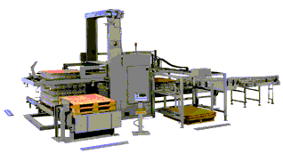

A-B-C manufactures a complete line of secondary packaging machinery. Since 1940 the A-B-C tradition of quality and craftsmanship has included case erectors, case sealers, automatic case packers, case palletizing and bottle handling systems. Machines are available in a full range of speeds and capabilities for low, medium or high volume packagers. ASME & SME (Society of Manufacturing Engineers) are joining together to experience a guided tour of A-B-C Packaging that will feature demonstrations of some of A-B-C’s palletizers as well as a new machine option, an over-lapping bag placing mechanism. Come see the innovative engineering incorporating the latest technology at A-B-C!

Date: | Wednesday, October 9, 2002
Location: | A-B-C Packaging Machine Corporation, 811 Live Oak Street, Tarpon Springs, FL 34689 (see map), (727) 937-5144, www.abcpackaging.com
Time: | Tours begin at 6:30 PM in groups of 10-15 members. Following the tour, we will have BBQ dinner at the site – courtesy of A-B-C Packaging Machine Corp.
Menu: | BBQ Beef and Pork Sandwiches, Baked Beans, Cole Slaw, Potato Salad & Sodas.
Price: | A minimum contribution of $5.00 per person is required (for partial support of the ASME student projects).
NOTE! | THIS MEETING IS LIMITED TO THE FIRST 35 RESERVATIONS
Reservations: | Reservations and cancellations are required by noon on Monday, Oct. 7, 2002. To make reservations, call Helen Prince at 727-734-5546. Make your checks payable to ASME-FWCS and mail to Helen Prince, 1515 Ruth Road, Dunedin, FL 34698-4416. All ASME dinner meetings are open to the general public. Please call BEFORE sending your check. If you make a reservation & do not cancel by noon, Oct. 7th, you will be billed.

Directions to A-B-C Packaging Machine Corporation, Tarpon Springs, FL
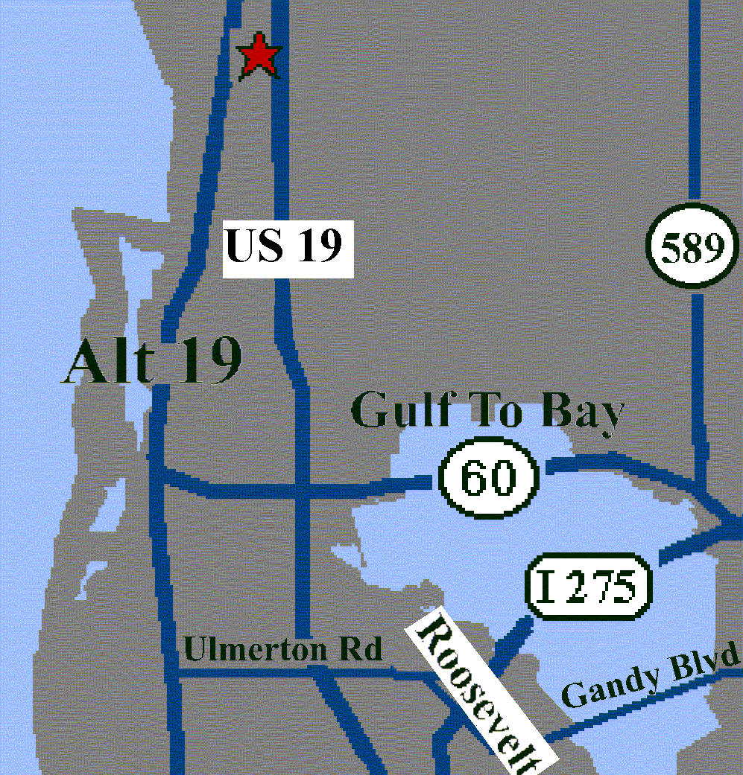 | 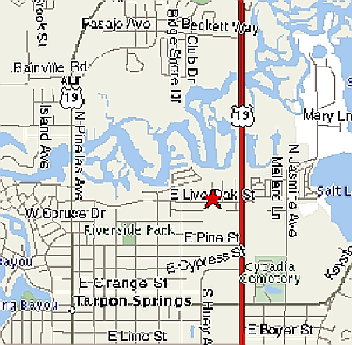

We thank these sponsors for supporting engineering educational activities with High School and University of South Florida Students:

INDUSTRY PARTNERS RECEPTION

The ASME FWCS Executive Committee will be hosting an industry reception on Thursday, October 24th beginning at 5:30 PM at the Holiday Inn Select in Clearwater. During the industry reception, Burt Dicht, ASME Southern Regional Office Director, will present local engineering managers with information about what ASME does and how they may obtain assistance from ASME for their employees. The reception provides engineering managers with an opportunity to meet with other engineering leaders and share their industry concerns. The goal of the reception is to discover how the FWCS can help engineering managers face these challenges as well as make engineering leaders aware of current ASME activities and benefits.

The last industry reception, held two years ago, was very successful and featured an overview of the 100+ technical courses available to managers including Codes & Standards, Elevators, Piping, and Welding. Also, Al Kurzenhauser presented a brief overview of the 20th century as the “Engineering Century” and how the 21st century promises new engineering innovations at an even faster pace. The reception was instrumental in focusing new efforts by the Society in meeting industry needs – including establishing the Continuing Education Institute of ASME.

If you know of any industry leaders who would be interested in an invitation to this event, please contact Al Kurzenhauser at 813-251-6403 or Mike Colitz at 813-227-6598. The industry reception will be held at the Holiday Inn Select, 3535 Ulmerton Road, Clearwater, located on north side of Ulmerton, about 1-½ miles west of 275 bridge and ½ mile west of Feather Sound Development. The Airco Golf Course is located behind the hotel.

Job Opportunity

A position is currently open for a Project Mechanical Engineer with a BSME; 5 years experience in product design and development of mechanisms; good creative, analytical and problem solving skills; & strong business office software experience. Experience with Pro/E a big plus. The position is located in TN with paid relocation and no travel required. The salary range is 45-60K.

The ideal candidate will have the ability to turn concepts into reality. Will prove a concept, get models, once proven, will turn over to the design group. Will apply and/or evaluate new technologies as they come in from inventors. Will design complex components & assemblies. Will complete products and do experimental analysis. Will perform complex calculations and validate the design. Will use CAD to document assigned projects. Will coordinate project activities with other departments and serve as a leader for line extensions or configuration projects. Will have design development experience in power tools, engines or other dynamic machines.

If you are interested in this position, please send resume and 3 professional references to:
Jeannie Abston ext. 206, McConnell, Mae & Miller, Inc., 29605 U.S. Hwy. 19 North, Ste. 360
Clearwater, FL 33761, P: 727 773-0306, F: 727 773-0248, JeannieAbston@worldnet.att.net

“SOVEREIGN OF THE SEA” ATMOSPHERE PROMOTES
CREATIVE THINKING DURING REGION XI PLS

This year’s Southeastern Region XI Professional Leadership Seminar (PLS) was held on the beautiful Royal Caribbean Lines “Sovereign of the Sea” on August 15 - 18th. FWCS Executive Board members, Al Kurzenhauser, John Mulvihill, Billy Adkins, Noel McCormick, and Paul Stevenson left Port Canaveral bound for Nassau and Cococay. This year’s PLS planning was especially successful in making this ASME event an outstanding family activity. ASME meetings were conveniently held in the early morning and late evening hours which allowed participants to see the sites and spend quality time with family. Some of the activities our FWCS leaders were involved in included a presentation by John Mulvihill on “Strategic Planning and How It Can Help Develop And Promote Section Activities.” Billy Adkins also presented the Regional Operating Board Membership Report. During the Friday evening session, several groups were formed to discuss various topics such as:
- Recruitment & Retention of New Officers (John Mulvihill)
- Programs for Young Engineers (Billy Adkins)
- Society Membership Retention & Growth (Noel McCormick)
- Senior Section and Student Section Interaction (Paul Stevenson)
- & Industry Relations and Interactions
During the Saturday morning session, several different groups were formed to brainstorm and problem-solve an assigned scenario. Each group had to develop and document a plan to accomplish a goal such as
- Planning a Professional Development Program (Noel McCormick, Team Leader; Paul Stevenson)
- Revitalizing a Weak or Inactive Section
- Organizing a Membership Recruitment and Retention Drive (John Mulvihill)
- Organizing a Section/Student Section Event
- Improving Attendance at Section Meetings (Billy Adkins)
During all of the sessions, Al Kurzenhauser acted as a roving facilitator, answering questions & providing input. Overall, this year’s PLS provided an exceptional atmosphere for creative thinking on ASME leadership techniques.

Don’t forget to sign up for this month’s PD Seminars on
Electronics Cooling (Oct. 26) and Shock & Vibration (Oct. 28-30!
2002 – 2003 Professional Development Tentative Schedule
For more information, contact Noel McCormick
(727) 735-9633 or noel@mccormicktech.com
Date | Activity |  | Instructor | Location
October 26 |  | Electronics Cooling Seminar | Daniel Jones, Raytheon | TECO ETRC, Tampa
October 28-30 (M – W) |  | Shock & Vibration Seminar. | Wayne Tustin, ERI | Raytheon, St. Pete
 |  | For additional information, and to sign up, visit:
 |  | http://www.equipment-reliability.com/course4.htm
November |  | Finance for Engineers | TBD | TECO ETRC, Tampa
January |  | Computational Fluids Seminar | Vendor Sponsor (TBD) | USF, Tampa
 |  | PE Review (TBD)
February |  | Project Management | TBD | TECO ETRC, Tampa
 |  | PE Review (TBD)
March |  | GD&T Seminar | Don Patz | TECO ETRC, Tampa
 |  | PE Review (TBD)
April |  | FEA Tools & Techniques | TBD | USF, Tampa
May |  | Communications Skills Seminar | TBD | TECO ETRC, Tampa

BE A PART OF A WINNING TEAM!
And have tons of fun!
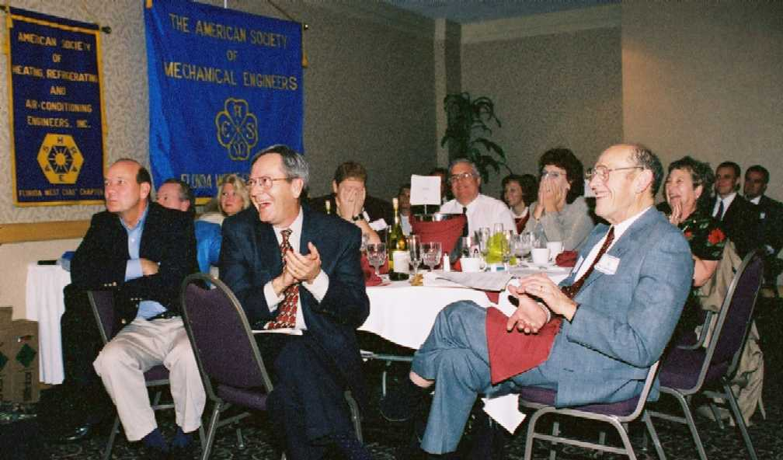
Above are some members of five engineering and technical Societies that planned and executed the most successful Celebrate Engineering 2002 Banquet and Event. Doesn’t this look like fun? Photographed during the banquet, everyone is enjoying our most successful Engineer's Week Banquet yet -- on 2/23/02!

As the event becomes embellished with new features, we are seeking more DEPs* who want to enhance their production planning skills, presence and charm. Those who willingly yearn for fun with the pros in the photo. And, continue to build a stronger Alliance of engineering professionals on the Florida West
Coast! The next CELEBRATE ENGINEERING BANQUET WILL BE at the A La Carte-Engineering Pavilion (Formerly Egypt Temple) on Friday, 2/21/03.
* Dynamic Engineering Pros

Contact Al Kurzenhauser (813-251-6403 or e: kurzenhauser@aol.com) and BE ALL YOU CAN BE!

The Deadline for ASME Membership Renewal is Here!

You can renew your membership by mail or by visiting www.asme.org/member! The deadline for renewal is October 1.

Young Engineers: The Value of your membership just increased…
If you have earned a baccalaureate degree or an advanced degree and you have been out of school four years or less you can take advantage of the new discounted member dues: 0 - 1 year after graduation, $45.00; 1 - 2 years after graduation, $62.00; 2 - 3 years after graduation, $79.00; 3 - 4 years after graduation, $96.00.

USF’s Mechanical Engineering Students Help the Disabled
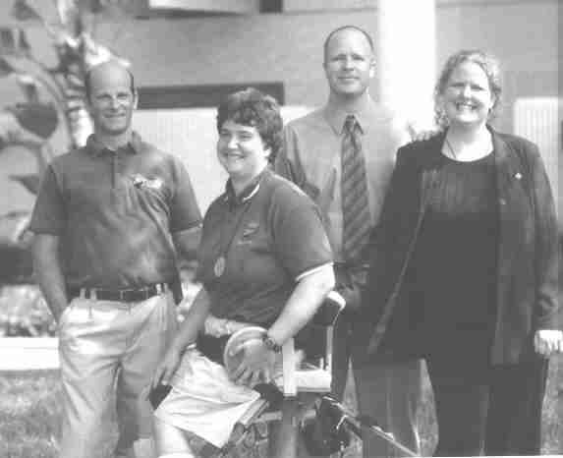 | 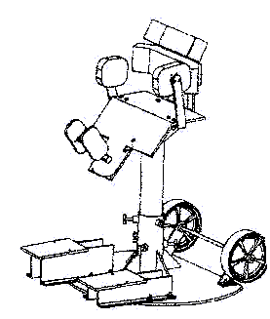
One of USF’s mechanical engineering Capstone Design teams conceived and built a field chair that enabled Robyn Stawski, second from left, to compete in the Paralympics World Championships. Stawski is pictured with members of the design team as featured in the Summer 2002 issue of USF Magazine. From left are James Stevens, Stawski, Andrew Martin, and Shari Brooks. Ginger Fisher and Warren Morrison also helped with the project. Stawski, who has cerebral palsy, used the chair for the first time May 4 at the Paralympics International Challenge in Orlando. She received the silver medal in the discus throw and advanced to the World Championships held in France in July. Congratulations to these USF students for their achievement in custom-made designs in Rehabilitative Engineering.

Lead the Way - Support your Profession and ME Students
Recruit New Members
Support the 2002-2003 Member-Get-A-Member Campaign now through June 30, 2003. When you recruit a new member, 50% of the first year dues will fund scholarships for ASME student members. It's easy to offer membership to your colleagues! Just follow these four steps:
- Print your name and membership I.D. on the Sponsor's Name line of the application. Make copies. http://www.asme.org/pdf/member/expresapnmme02.pdf
- Schedule time to discuss the benefits of joining ASME and distribute membership applications to your colleagues. http://www.asme.org/member/benefits/sellsheet.html
- Send a personalized email inviting your colleagues to join. Invite your colleagues to a FWCS meeting to show them how much ASME has to offer. Remember, the FWCS offers a free dinner to new members when they attend their first meeting! If you need an Application call or e-mail Bill Adkins: 727-539-4702; billy.adkins@honeywell.com.
- Follow up with new members that you recruited to welcome them to ASME.

Visit http://www.asme.org/membershipdrive/ to learn more about the campaign and resources to get started today.
2002 ASME INTERNATIONAL MECHANICAL ENGINEERING
CONGRESS & EXPOSITION

Nov. 17-22, 2002
New Orleans, Louisiana


This year’s Congress & Exposition will feature:

- Eight extended programs focusing on Nanotechnology, MEMS, Biomedical Technology, Transportation, Engineering Business Management, Energy, Electrical Systems and Photonics Design
- R&D Expo — a new exhibit where company representatives supply solutions to workplace problems Electrical Systems Design, Energy, Engineering. More info is available at www.rdexpo.com
- ASME Career Fair in New Orleans, November 19 – 20, is open to all levels of mechanical engineers, including entry-level, senior and management positions. | 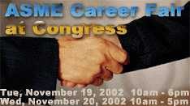
- 22nd Young Engineers Forum: Career Essentials, Sunday, November 17, 2002 held in conjunction with the 2002 ASME International Mechanical Engineers Congress & Exposition | 

Log on to http://www.asme.org/Congress to search the program database for sessions, events and papers that best meet your needs.

Keep Your Address Information
Up-to-Date!
Did you know that newsletters with incorrect addresses cause delays, cost extra postage for your Section, and extra work for volunteers, who must correct addresses and re-mail newsletters? To update your contact information please call Helen Prince at 727-734-5546.

FLORIDA WEST COAST SECTION OFFICERS FOR 2002-2003
CHAIR | VICE CHAIR | VICE CHAIR – PROGRAMS | TREASURER | SECRETARY
Michael Colitz, III  Holland & Knight LLP  400 N. Ashley Drive.  Tampa, FL 33602  (813) 227-6598  Fax: (813) 229-0134 | Carl Riddlemoser  ATC Assoc., Inc.  5801 Benjamin CTR Dr.  Suite 101, Tampa 33634  (813) 932-8960 ext. 245 | Stephen Elting  ABC Packaging Co.  811 Live Oak Dr.  Tarpon Springs, FL 34689-4199  (727) 937-5144 | Robert W. Andrew  Hudson Pump & Equipment  3524 Craftsman Blvd.  Lakeland, FL 33803  (863) 665-7867 | Robert F. Visbisky, PE  (813) 968-9382
FLORIDA WEST COAST SECTION EXECUTIVE BOARD MEMBERS FOR 2002-2003
William P. Adkins, PE  (727) 539-4702 | Al Kurzenhauser  (813) 251-6403 | John Mulvihill  (813) 749-1134 | Dr. Robert Pennington, II  (727) 345-6885 | Aimee Taylor  (941) 756-2594
Noel McCormick  (727) 735-9633 | Dr. Ronald L. Mann  (727) 938-1645 | Helen Prince  (727) 734-5546 | Bill Tarver  (727) 539-4307 | Richard O. Fraze  (727) 522-6759
Paul Stevenson  (727) 735-9633 | Dr. R. Gerry Miller, PE  (727) 397-6807 | Clarence Prince, PE  (727) 734-5546 | Chester J. Ugan  (727) 527-8191
Adam D. Mainzer  (813) 221-1222 | Tim Hunt, PE  (727) 734-0026 | Adam Jenkins  (727) 345-7085 | Neville G.P. Brass  (727) 397-2737

 |  |  | Non-profit org.  U.S. Postage  PAID  Tampa, Florida  Permit No. 1610
 | Florida West Coast Section  1515 Ruth Road  Dunedin, FL 34698 | Address Service Requested

