
May 2002, Volume 6 Issue 9
ASME NEWS & VIEWS
Published monthly except July & August
A.S.M.E. Florida West Coast Section
1515 Ruth Road
Dunedin, FL 34698
ASME-FWCS PRESENTS SPEAKER HOLLY GREENING OF THE TAMPA BAY ESTUARY PROGRAM ON
NUTRIENT MANAGEMENT AND SEAGRASS RESTORATION IN TAMPA BAY: A PUBLIC/PRIVATE PARTNERSHIP
MAY 8, 2002

Tampa Bay is Florida's largest open-water estuary. Popular for sport and recreation, the bay supports one of the world's most productive natural systems. After decades of pollution, Tampa Bay is coming back to life, assuming its position as the shimmering economic and environmental centerpiece of the Southwest Florida region. Tampa Bay was designated an "estuary of national significance" by Congress in 1990, paving the way for development of a long-term blueprint for bay restoration through the Tampa Bay National Estuary Program. The Tampa Bay Program is a partnership of Pinellas, Hillsborough and Manatee counties, the cities of Tampa, St. Petersburg and Clearwater, FDEP, SWFWMD and the U.S. EPA which works closely with local industry. The Program's emphasis on public and private sector cooperation is serving as a model for achieving significant environmental goals while embracing local business interests and concerns. Holly Greening is the Senior Scientist for the Tampa Bay Estuary Program. Ms Greening has designed and directed numerous scientific studies, investigating bay impacts from stormwater runoff, freshwater inflows from tributaries, air pollution and toxic contaminants. She also has supervised development of TBEP's habitat restoration strategy, which emphasizes restoration of low-salinity tidal stream areas that provide vital nursery habitat to juvenile fish.
Date: Wednesday, May 8, 2002

Location: Radisson Bay Harbor Hotel (See Map on back page)

Time: Social from 6–7 PM, Dinner starts at 7PM, followed by the program

Menu: Pot Roast and Mashed Potatoes, Garden Salad, Vegetable DeJour, Rolls, Coffee or Tea, Deep Dish Apple Pie

Price: Members, and Guests $18.00 per person, includes tax and gratuity
ASME Students: $9.00

Reservations: Reservations and cancellations are required by noon on Monday, May 6, 2002. To make reservations, call Helen Prince at 727-734-5546. Make your checks payable to: ASME-FWCS, and mail to Helen Prince, 1515 Ruth Road, Dunedin, FL 34698. All ASME dinner meetings are open to the general public. Please call BEFORE sending check. If you make a reservation & do not cancel by May 6, you will be billed.

USF STUDENTS ATTEND REGIONAL STUDENT CONFERENCE
by Michael U. Jurczyk, Corresponding Secretary

This year’s ASME Regional Student Conference, RSC, was held in Jackson, Mississippi, from April 4th to April 6th. After a “short” fourteen-hour drive from Tampa to Jackson, the six student representatives for the ASME section at the University of South Florida finally arrived at the Hilton. The six representatives were ASME Chair Michael Berlin, Mentoring Program Chair Wes Callahan, Corresponding Secretary Michael Jurczyk, Community Service Chair Jason Klar, Nick Snapp, and Recording Secretary / Ingersoll-Rand Contest Representative Aaron Stolpe. After quickly moving all belongings into the two hotel rooms they met up with several known faces from previous year’s ASME RSC and the Regional Student Leadership Seminar.
That evening, most students checked in and enjoyed a small dinner buffet with cheese and crackers as well as fresh fruit. K.R. Rao, Regional Vice President of ASME, went around the room and took some time to talk to each student section about the numerous benefits of being an ASME member after graduation. After about an hour and a half of socializing, a mystery design contest was held to serve as an icebreaker and in order to meet students from other universities. Several teams of about five people, each person from a different university than the others, were formed and given the task of building a self-propelled vehicle made up of several parts. The parts supplied to each team consisted of CD’s, a mousetrap, a few rubber bands and a piece of styrofoam board. After approximately forty-five minutes, the cars built by the teams were run against each other, and the winner of each run-off advanced to the next round. Jason Klar, from USF made it into the final round with his team’s design and unfortunately placed “only” second since their car encountered technical difficulties. All in all, the design contest was a huge success since all participants had a lot of fun and since several new friends were made.
Friday morning, everybody gathered to enjoy a continental breakfast with fruits and sweet pieces along with a lot of coffee. After breakfast, the regional student conference was officially opened, and the poster design contest and website design contest began in which several universities competed. Students then had the chance to view the competitors’ entrees and make their own judgments as to whose entrée was the best, while the judges had already made their decision.
After a good lunch, the old guard presentations began simultaneously in three different rooms. The presentations ranged in subject from a “Redesign of a dishwasher with capacity in mind” to “Fuel cells.” Two USF representatives, Nick Snapp and Michael Jurczyk were amongst the presenters. Nick Snapp presented his senior design project about a collapsible scooter kit, while Michael Jurczyk gave a presentation on his work with teleoperation and sensor-based assistance in rehabilitation engineering. Both presenters also gave their presentation at the Student Paper’s Night on March 27th.
For dinner, all RSC and RAC attendees were invited to Entergy for a wonderful dinner buffet followed by an excellent and informative presentation on Nuclear Energy. Just before the student design contest started, the three finalists for the Old Guard oral Presentation were announced. Nick Snapp and Michael Jurczyk were amongst the three finalists that were to compete the following day. Then, the design contest began. Each competing team had two minutes to set up their apparatus that was to launch thirty baseballs into a goal box with three holes within two minutes. There were many innovative and unique designs and everybody had a great time. Unfortunately, only four of the designs were able to launch baseballs into the goal. The winner was the team that launched the most baseballs within the least amount of time into the goal. After the winner was announced, all attendees went back to the hotel or to local attractions to have some fun.
After the opening of the RAC and the old guard run-offs, the honors and awards luncheon was held to conclude the RSC. The student section of the University of South Florida was awarded a vast number of awards. Nick Snapp and Michael Jurczyk won the award for best technical presentation of their group. Nick Snapp also won first place in the Old Guard Competition, which includes a trip to the ASME Congress in New Orleans later this year where he will compete against the other regions’ winners. Michael Jurczyk placed third in the Old Guard Competition.
USF also won third place in the Ingersoll-Rand contest, a contest to measure the performance of each student section against other. The contest is based on a wide variety of activities ranging from meetings to social activities. In addition, USF won a special prize since it was one of a few universities to obtain very high point scores last year, thus making Region XI achieve the best performance in the country last year.
Finally, Aaron Stolpe received an award for his outstanding service to the USF Student Section during the past year. He also became the region’s Charles T. Main nominee. The Charles T. Main Award honors a student for leadership and service qualities contributing to programs and operations of an ASME student section.
All in all, this year’s Regional Student Conference in Jackson, Mississippi, was a huge success for the Student Chapter of the Florida West Coast Section. I am sure everybody is looking forward to next year’s RSC as well as the upcoming RSLS and Nick Snapp’s presentation at the National Congress in New Orleans.

Don’t forget the final event of the year- June 12th, '02: Honors & Awards, details will be announced in the next newsletter.

APRIL’S MEETING: COMPUTER AIDED ENGINEERING

Last month’s meeting featured Noel McCormick of McCormick Technology Corporation who spoke on the latest advances in computer aided engineering (CAE). Mr. McCormick, who is currently serving as the FWCS’ Professional Development Chair, demonstrated various CAE software, including Pro/Engineer. The presentation provided insight into the use of software for selection of materials and parts, engineering design and, ultimately, design analysis. Mr. McCormick also spoke on the likely advances to occur with CAE in the years to come. FWCS thanks Mr. McCormick for taking the time to speak with us and for his continuing efforts as Professional Development Chair. More information on McCormick Technology can be found at www.mccormicktech.com.

2001-2002 Member-Get-A-Member Campaign
Help ASME International serve the needs of the mechanical engineering community by sponsoring new members. With each new member, you recruit, 50 percent of the first year’s dues will be spent on scholarships for mechanical engineering students.
For complete program details, log onto http://www.asme.org/membershipdrive

We thank these sponsors for supporting engineering educational activities with High School and University of South Florida Students:

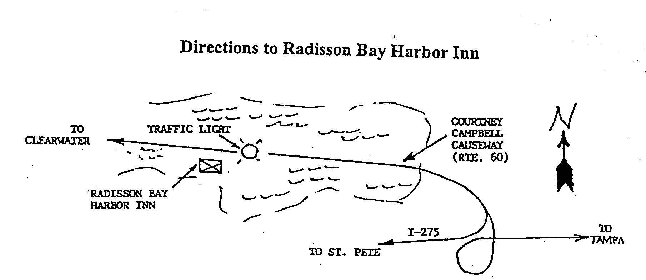

Keep Your Address Information
Up-to-Date Online!
Did you know that newsletters with incorrect addresses cause delays, cost extra postage for your Section, and extra work for volunteers, who must correct addresses and re-mail newsletters? To update your contact information please call Helen Prince at 727-734-5546.

ELECTRONIC AGE
If you would like to receive our newsletter via E-mail, please send your address to andrewr@asme.org and put newsletter in the subject line. All addresses will be kept confidential. For the latest information on ASME events, check out the Florida West Coast Section web page. http://www.bobandrew.com/asme We have links to many important and interesting sites for jobs, codes and standards, etc

FLORIDA WEST COAST SECTION OFFICERS FOR 2001-2002
CHAIR  Neville G. P. Brass  (727) 397-2737  12040 108th Ave. N  Largo, Fl  33778-3532 | VICE CHAIR  Michael J. Colitz, III  Holland & Knight LLP  400 N. Ashley Drive.  Tampa, FL 33602  813-227-6598  Newsletter Fax  813 229-0134 | VICECHAIR-PROGRAMS  Carl Riddlemoser  ATC Assoc., Inc.  5801 Benjamin CTR Dr. Suite 101, Tampa  FL 33634  813-889-8960 ext 245 |  | TREASURER  Tim Hunt, P.E.  Rhunts Engineering  568 Baywood Dr. N.  Dunedin, FL 34698  727-734-0026 |  | ACTING SECRETARY  Robert W. Andrew  Hudson Pump & Equipment  3524 Craftsman Blvd.  Lakeland, FL 33803  863-665-7867
FLORIDA WEST COAST SECTION EXECUTIVE BOARD MEMBERS FOR 2001-2002
William P. Adkins PE  727-539-4702  Noel McCormick  727-735-9633  Karen Vallar  727-595-6366 | Al Kurzenhauser  813-251-6403  Dr. Ronald L. Mann  727-938-1645  Dr R. Gerry Miller  727-397-6807 |  | John Mulvihill  813-855-4693 x23  Helen Prince  727-734-5546  Clarence Prince PE  727-734-5546 |  | Robert Pennington  813-974-8284  Bill Tarver  727-539-4307  Chester J. Ugan  727-527-8191 |  | Robert F. Visbisky PE  813-630-6998  James R. Windgassen  727-791-7599  Richard O. Fraze  727-522-6759  Stephen D. Elting  813-831-7286

TPA1 #1217679 v2

