
January 2002, Volume 6 Issue 5
ASME NEWS & VIEWS
Published monthly except July & August
A.S.M.E. Florida West Coast Section
1515 Ruth Road
Dunedin, FL 34698
FWCS TOUR OF YBOR CITY RAIL PROJECT
AND DINNER AT SPAGHETTI WAREHOUSE
WEDNESDAY JANUARY 16, 2001

FWCS will host a presentation and tour of the on-going construction of the Ybor City railway. Scheduled for completion this May, the project will link downtown Tampa with Ybor City and the Channelside district. The railway will consist of eight trolley cars, which will be modeled after the trolleys that used to run on the streets of Ybor during the early 1900's. The cars will be powered by overhead electrical lines, and unlike the trolleys of yesteryear, the new cars will be fully air conditioned. Current construction involves the laying of railway and power lines. This will be a unique tour and a not to be missed opportunity. Prior to the tour the section will meet at the Spaghetti Warehouse for drinks and dinner.


Where: The Spaghetti Warehouse 1911 N. 13th Street Ybor City, Florida (see map on back page for directions).

Dinner: Spaghetti, Lasagna, Fettucini Alfredo or Baked Penne Pasta, house salad, sourdough bread, ice tea, soft drink or coffee.

Time: 6PM Social Hour, 7PM dinner, followed by tour at 8PM

Cost: ASME Members and guests: $15.00
ASME Students: $8.00.

Reservations and cancellations are required by 6PM Monday January 14th. To make reservations, call Helen Prince at 727-734-5546. Paying in advance by check would be appreciated. Make your check payable to ASME-FWCS and mail to Helen Prince, 1515 Ruth Road, Dunedin, FL 34698. All ASME dinner meetings are open to the general public.

CELEBRATE ENGINEERING 2002 BANQUET

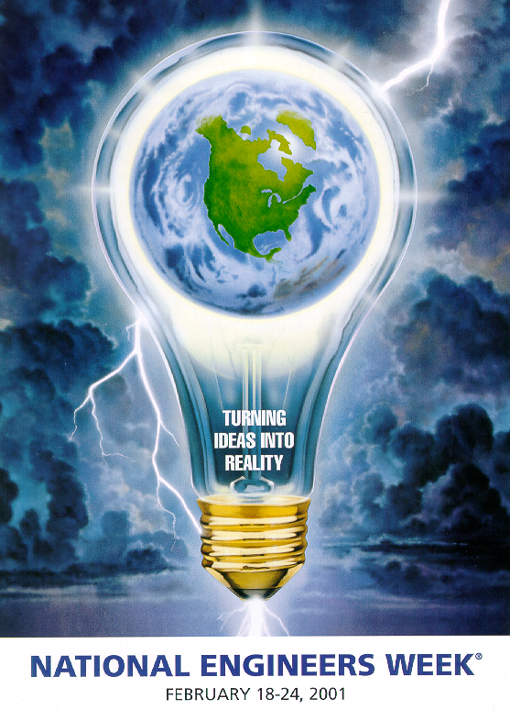
Date/Time: Saturday, February 23, 2002;5:30PM Social 7:00PM Dinner; 8:00PM Program
Location: Holiday Inn City Centre, 111 West Fortune Street, Tampa, FL 33602, (813) 223-1351
Speaker: William Dean, ASME Distinguished Speaker
Entertainment: To Be Determined
Door Prize: Given throughout the evening
Cost: $20.00 per person.
2002 Banquet Sponsors – Advanced Designs & Equipment, Association for Facilities Engineering, Florida Fluid System Technologies Inc., Honeywell, Malcome Pirnie, McQuay International, Seminole Electric Cooperative Inc., Southern Marketing Associates, Tampa Armature Works, Tampa Electric Company, and York International.
Eight seat tables are available for corporate reservations. Please call Quang Tang at (813) 739-1222 or email q.tang@ieee.org for more information.

Nominations for Engineer of the Year Award

FWCS is now accepting nominations for the Engineer of the Year award to be presented at the joint banquet on February 23rd. The following are some of the factors which may be considered in selecting this year's award winner: Education; Registration (EI, PE);Engineering Employment; Engineering Contributions/Achievements; Honors/Awards Received; Military Service; Membership in professional associations (nonASME); ASME Activities; Community Activities; Letters of Recommendations both personal and professional. FWCS encourages its members to nominate engineering colleagues from throughout the west coast of Florida. Please contact Bill Adkins, PE (727-539-4702) with any submissions.

FWCS CELEBRATES CHRISTMAS AT MAC DILL
On December 7, 2001 the FWCS membership met at the Mac Dill Officers' club for Christmas dinner. Governor Al Kurzenhauser gave a short talk on how the engineering profession can meet the challenges presented to our nation since the tragedy of September 11th. The section also held a wine auction to raise money for both the student design contest and the Engineering Week Banquet. The grand finale of the evening was a white elephant gift exchange. The evening give FWCS members an opportunity to interact with one another and also gave members a behind the scenes view of one of our nations most important military bases. FWCS thanks all those who attended and graciously donated money to our sections many worthwhile causes.
UPCOMING FWCS EVENTS FOR 2001-2002- Feb. 23rd, '02: Engineer’s Week Banquet (confirmed); Mar. 27th, '02: Student Papers Night (confirmed); April. 10th, '02: William Dean, Contracting & Manufacturing; May 8th, '02: Tampa Bay Estuary Program; June 12th, '02: Honors & Awards

New Dimensions in Multidisciplinary Thinking: Issues, Trends, and Implications for Mechanical Engineers and ASME:
The Committee on Issues Identification has released a new report that focuses on issues and trends that result from the expanded role of multidisciplinary engineers in all sectors of industry and government. It explores the nature of multidisciplinary engineering - where and how it is being employed - and examines its impacts on mechanical engineering practice, education, professional licensure and the research and development environment.
Finally, the report considers the impact of multidisciplinary thinking generally on the field of mechanical engineering, and on ASME International as an organization serving the mechanical engineering profession.
Copies of the report may be ordered through ASME Information Central at 1-800-THE-ASME (order #AF0201) or through the on-line Publications Catalog at http://www.asme.org/catalog. The cost is $15 per copy for ASME members; $20 per copy for non-members.
For additional information, contact Mary James Legatski in the ASME Washington office at 202-785-3756 or at legatskim@asme.org.

CLARENCE F. & HELEN G. PRINCE SCHOLARSHIP AWARD
The FWCS awarded the this year's Clarence F. & Helen G. Prince Scholarship to Michael U. Jurczyk. Michael is a Mechanical Engineering student at the University of South Florida where he works as a research assistant in the field of controls and robotics. Other applicants were Aaron J. Stolpe and Andrew C. Martin. All of this year's applicants had very impressive academic track records and the judging was very difficult. FWCS thanks all those who applied, as well as the Prince's for their continuing generosity.

Young Engineers Award
ASME International wants to give $5,000 plus a prepaid life membership to a young ASME member that has done an outstanding job in their profession, community and the work of ASME. Nominate a Young Engineer for the Old Guard Young Engineers Award Today!
http://www.asme.org/cma/og/youngengineer.html.

Time to Cram for the PE Exam!
ASME International offers three courses of study and discounts for ASME Members on these products. Sign up now to get ready for the April exam!
- PE Video – 16 videotape program, self-study
- PE Online – instructor-assisted self-study
- PE Exam Review Plus (PE Video + PE Online)
For details, please visit our Website (http://www.asme.org/pro_dev/exam_preparation_courses.htm)
Contact Thomas Kuehl, 212-591-8013 (kuehlt@asme.org) or
Kathy J. Warner, 212-591-7411 (warnerk@asme.org).

We thank these sponsors for supporting engineering educational activities with High School and University of South Florida Students:

MAP TO SPAGHETTI WAREHOUSE
1911 N. 13TH STREET, YBOR CITY
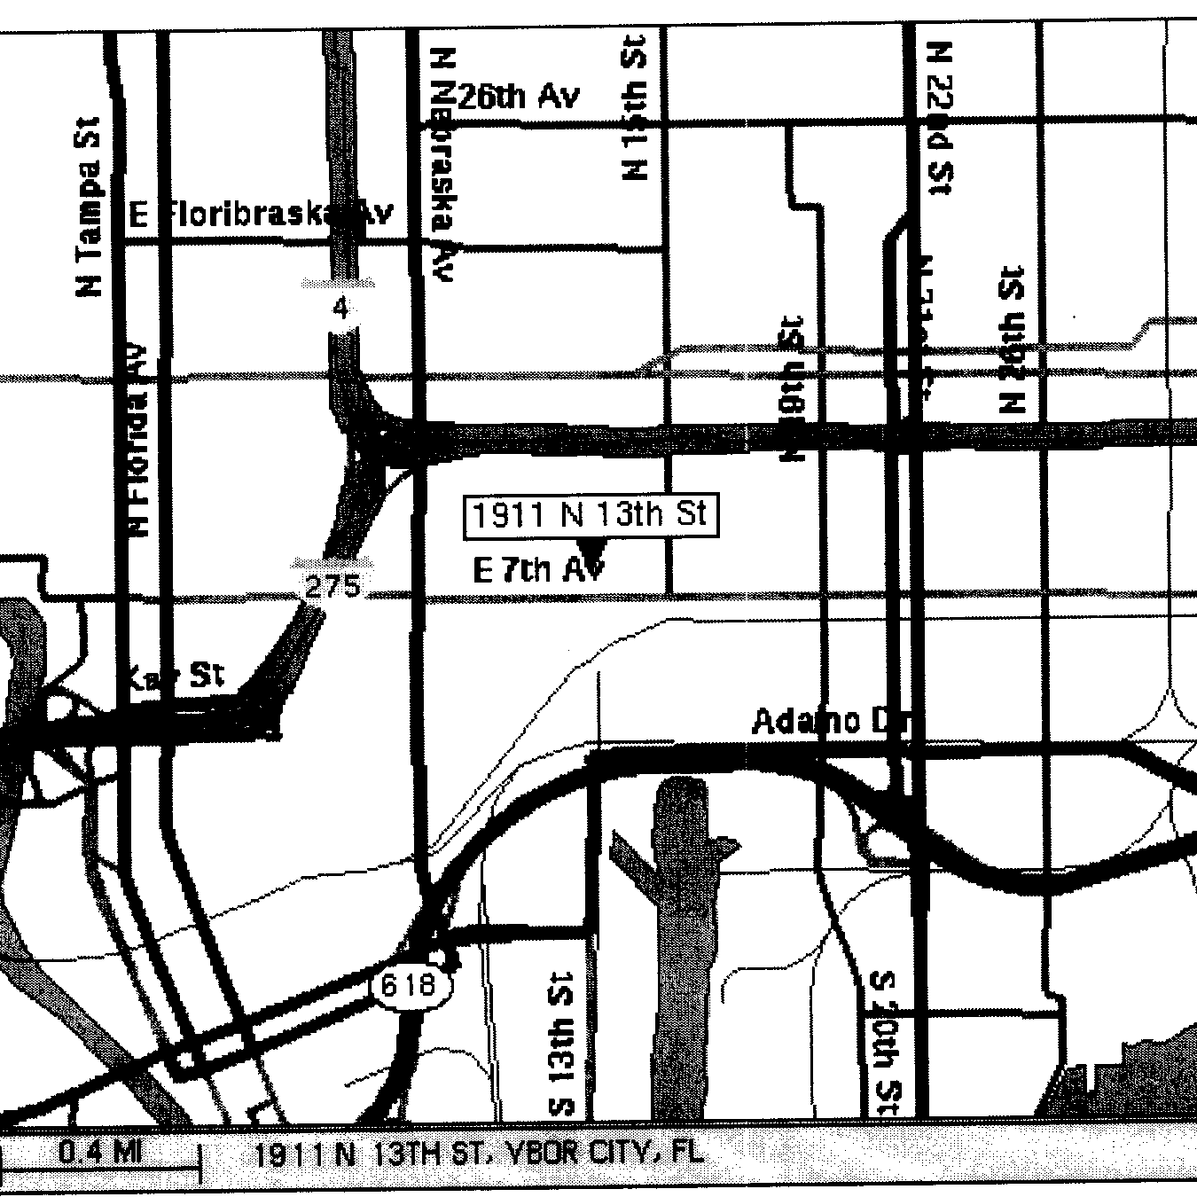

Keep Your Address Information
Up-to-Date Online!
Did you know that newsletters with incorrect addresses cause delays, cost extra postage for your Section, and extra work for volunteers, who must correct addresses and re-mail newsletters? To update your contact information please call Helen Prince at 727-734-5546.

ELECTRONIC AGE
If you would like to receive our newsletter via E-mail, please send your address to andrewr@asme.org and put newsletter in the subject line. All addresses will be kept confidential. For the latest information on ASME events, check out the Florida West Coast Section web page. http://www.bobandrew.com/asme We have links to many important and interesting sites for jobs, codes and standards, etc

FLORIDA WEST COAST SECTION OFFICERS FOR 2001-2002
CHAIR  Neville G. P. Brass  (727) 397-2737  12040 108th Ave. N  Largo, Fl  33778-3532 | VICE CHAIR  Michael J. Colitz, III  Holland & Knight LLP  400 N. Ashley Drive.  Tampa, FL 33602  813-227-6598  Newsletter Fax  813 229-0134 | VICECHAIR-PROGRAMS  Carl Riddlemoser  ATC Assoc., Inc.  5801 Benjamin CTR Dr. Suite 101, Tampa  FL 33634  813-889-8960 ext 245 |  | TREASURER  Tim Hunt, P.E.  Rhunts Engineering  568 Baywood Dr. N.  Dunedin, FL 34695  727-734-0026 |  | ACTING SECRETARY  Robert W. Andrew  Hudson Pump & Equipment  3524 Craftsman Blvd.  Lakeland, FL 33803  863-665-7867
FLORIDA WEST COAST SECTION EXECUTIVE BOARD MEMBERS FOR 2001-2002
William P. Adkins PE  727-539-4702  Noel McCormick  727-735-9633  Karen Vallar  727-595-6366 | Al Kurzenhauser  813-251-6403  Dr. Ronald L. Mann  727-938-1645  Dr R. Gerry Miller  727-397-6807 |  | John Mulvihill  813-855-4693 x23  Helen Prince  727-734-5546  Clarence Prince PE  727-734-5546 |  | Robert Pennington  813-974-8284  Bill Tarver  727-539-4307  Chester J. Ugan  727-527-8191 |  | Robert F. Visbisky PE  813-630-6998  James R. Windgassen  727-791-7599  Richard O. Fraze  727-522-6759  Stephen D. Elting  813-831-7286

TPA1 #1190517 v1

