January 2001, Volume 5 Issue 5

THE GREATEST PLANT TOUR IN TAMPA BAY
Start the Millennium Right!!
TAMPA ARMATURE WORKS
Wednesday, January 17, 2001 From 6:00 PM to 7:30 PM

Founded in 1921 Tampa Armature Works, has prospered by adapting its repair processes, equipment, technologies and philosophies to meet their expanding customers' changing needs. It is a very strong customer focussed repair/rebuild/rewind shop that believes in and executes superb customer service.

WHAT WILL YOU SEE?
A very large shop capable of repairing all rotating and reciprocating equipment likely to be used by most manufacturers, power stations, water/sewage plants, and mining companies in the Southeast. They have automatic/NC lathes, turning centers and extra long engine lathes. TAW can rebuild 500 HP Motors, stators, switch gears, electrical electronic control equipment, etc. If it is old equipment, and the manufacturer went out of business 50 years ago, they have the ability to research winding data/characteristics. Not only will TAW repair/rebuild your equipment, they would be willing to take over reinstallation, operational test and turnkey it back to you. FAST!

WHY VISIT TAMPA ARMATURE WORKS?
It is essential professional education for any engineer working in the real industrial world. You will learn new ways of making repairs and maintenance. You will see modern REPAIR /REWIND processes to meet today's more stringent needs! They are an organization conditioned to customer service (plus) do the work RIGHT NOW! From Miami to Pennsylvania, the Mississippi River, South America and the Middle East.

DINNER
The famous Spaghetti Warehouse located in Ybor Square,YBOR City is our stop for supper, after the tour (See Map on back page for direction to TAW and the Spaghetti Warehouse in YBOR CITY 2 miles away).

Delicious Italian Dishes such as : (Your choice, one only) 15 Layer Baked Lasagna, Cannelloni Florentine, Grilled Chicken Marinara, Four Cheese Manicotti and, with every dish, Fresh Italian salad, their San Francisco Sourdough Bread, Iced tea, Ybor Square-coffee, softdrinks. Cost $13. Parking is 50 cents per hour, by machine at large 13th St. lot facing the Ybor Square building. (Near Tampa Electric's Data center to the west)

Reservations and cancellations are required by 6PM Monday January 15th. To make reservations for the Dinner and Tour, call Helen Prince at 727-734-5546. Paying in advance by check would be appreciated. Make your check payable to ASME-FWCS and mail to Helen Prince, 1515 Ruth Road, Dunedin, FL 34698. All ASME dinner meetings are open to the general public.

WINE AUCTION HIGHLIGHTS FWCS HOLIDAY DINNER

FWCS held its Holiday Dinner on December 7th at the Mac Dill Officer's Club. The Officer's Club was a wonderful setting with a great view of Tampa Bay. Governor Al Kurzenhauser lead the section in a moment of silence to observe the 59th year after the attack on Pearl Harbor. Several new attendees were present and the dinner was a nice introduction to those new FWCS members. After dinner all attendees participated in a $5 White Elephant gift exchange. The main event after dinner was an auction for wines, (80 bottles) which the section had purchased as closeouts indirectly from distributors. Al gave a brief description of each wine and its relationship to other wines of the world. We had wines from the US, Chile, Australia, Bulgaria, Romania, Germany and France. The section netted nearly $200 for use to support attendance at the Celebrate Engineering Banquet in February. Section members also brought canned gifts for donation to the Divine Providence food bank. The donations filled several grocery bags and will undoubtedly be a welcome gift to a needy family. FWCS wishes its membership a happy and safe holiday season.

UPCOMING FWCS EVENTS
January 24 Executive Board Meeting at Celotex; March 24 Golf Tourney- Seminole C.C.; March 21st – Student Papers night at U.S.F.; April 11th – Fed Co. tour; May 9th -Publix DairyTour ; June 13th – Speaker on bio-med topic at Tampa Radisson Bay Harbor.

CAREER OPPORTUNITY

Hi-Tech Electronic Displays in Clearwater has an opening for a design engineer with strong AutoCad skills, project management experience, and electrical/electronic circuit knowledge to design electronic LED signs (refer to our website, hitechled.com).

Forward resume to Lois Holland (727) 524-6655 (fax) or loish@hitechled.com.

CAREER EXPO
Presented by ASME International
Tues., March 6, 8am-5pm Wed., March 7, 8am-5pm Grand Ballroom, McCormick Place South Chicago, Ill.
Looking for a job or simply curious? Meet face-to-face with Recruiters and Hiring Managers from leading companies. Consider thousands of engineering job openings. Discover job opportunities you won’t find anywhere else. Free admission to job candidates. Bring plenty of resumes! Find out what potential employers are looking for.

FWCS SPONSORS MECHANICAL ENGINEERING REVIEW COURSE
The mechanical engineering P.E. review course starts this January at U.S.F. The class includes 10 weekly sessions conducted by the U.S.F. faculty. Please contact Carl Riddlemoser for details (813) 889-8960.

THE STUFF YOU DIDN'T LEARN IN ENGINEERING SCHOOL
The Florida West Coast Section of ASME International presents a seminar providing skills to increase your success and satisfaction in the workplace as a leader, team member, and advocate for the engineering viewpoint.
In this plain-English, no-nonsense seminar, you will gain practical, down-to-earth techniques on project management, and on working with management, peers, and subordinates to increase your confidence, success, and satisfaction on the job.
Where: The Energy Technology Resource Center Auditorium 2 3650 Spectrum Boulevard Tampa, Florida

When: Friday, January 19, 2001.Check-in at 8:00 a.m. and the seminar will begin at 8:30AM. The lunch break is 12:00 to 1:00 p.m. The seminar concludes at 4:00 p.m.

For more information regarding this seminar, call: Carl Riddlemoser at 813-889-8960 or Burton Dicht at 800-445-2388

NEW MEMBER RECRUITMENT NOW UNDERWAY
FWCS strongly encourages its members to help the section meet its Membership Development quota. Please solicit your engineering colleagues & associates and let them know how much ASME has to offer in terms of technical info, meetings, and benefits. If you need an Application they can call or e-mail Bill Adkins: 727-539-4702; billy.adkins@honeywell.com. ASME applications can also be down-loaded from the ASME web page.

Nominations for Engineer of the Year Award

FWCS is now accepting nominations for the Engineer of the Year award to be presented at the joint ASME, IEEE, SOLE banquet on February 17th. This years banquet will be held at the Ramada Inn on Kennedy Boulevard, see insert for details. The following are some of the factors which may be considered in selecting this year's award winner: Education; Registration (EI, PE);Engineering Employment; Engineering Contributions/Achievements; Honors/Awards Received; Military Service; Membership in professional associations (nonASME); ASME Activities; Community Activities; Letters of Recommendations both personal and professional. FWCS encourages its members to nominate engineering colleagues from throughout the west coast of Florida. The deadline for submissions is Monday January 22, 2001. Please contact Bill Adkins, PE (727-539-4702) with any submissions.

We thank these sponsors for supporting engineering educational activities with High School and University of South Florida Students:

MAP TO TAW AND SPAGHETTI WAREHOUSE
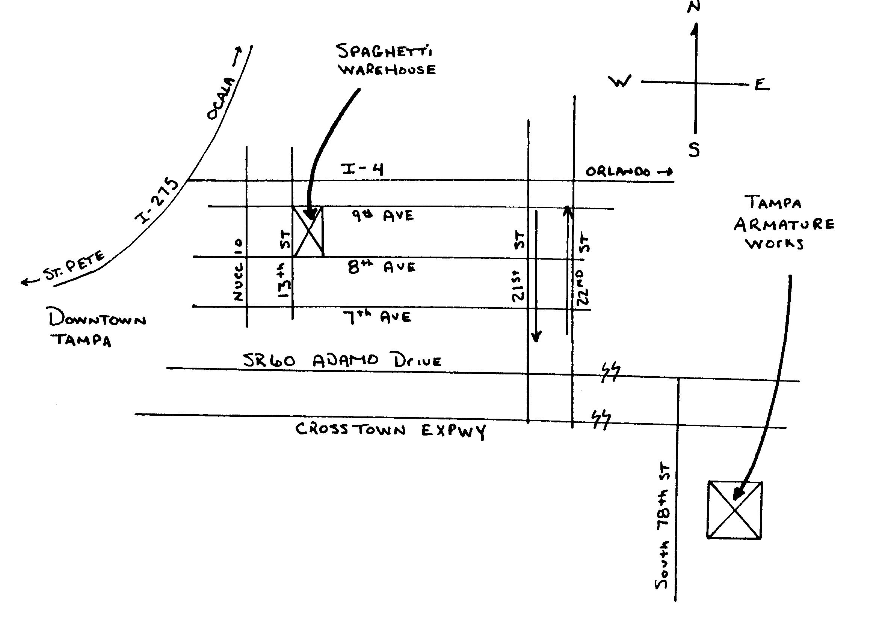
TAW is located at 440 South 78th Street, in the east of Tampa, 200 yards South of the Crosstown (Lee Roy Selmon) Expressway. This is the best access from Gandy Blvd. Traveling east to Brandon, use the 78th St turnoff (shortly after the toll booth). No exit from Brandon's direction at 78th St. Use SR 60.

ELECTRONIC AGE

If you would like to receive our newsletter via E-mail, please send your address to andrewr@asme.org and put newsletter in the subject line. All addresses will be kept confidential. For the latest information on ASME events, check out the Florida West Coast Section web page. http://www.bobandrew.com/asme We have links to many important and interesting sites for jobs, codes and standards, etc..

FLORIDA WEST COAST SECTION OFFICERS FOR 2000-2001
CHAIR  Neville G. P. Brass  Lazzara Yachts  5250 W. Tyson Av.  Tampa, FL 33611  813-839-0090 | VICE CHAIR  Tim Hunt, P.E.  Rhunts Engineering  568 Baywood Dr. N.  Dunedin, FL 34695  727-734-0026 | VICECHAIR-PROGRAMS  Robert W. Andrew  Hudson Pump & Equipment  3524 Craftsman Blvd.  Lakeland, FL 33803  863-665-7867 |  | TREASURER  Karen Vallar  12800-7852 Vonn Rd.  Largo, FL 33774  727-595-6366 or |  | SECRETARY  Michael J. Colitz, III  Holland & Knight  400 N. Ashley Drive.  Tampa, FL 33602  813-227-6598  Newsletter Fax  813 229-0134
FLORIDA WEST COAST SECTION EXECUTIVE BOARD MEMBERS FOR 2000-2001
William P. Adkins PE  727-539-4702  Gene Allen  727-588-0147  Katharine Speltz  813-269-9319 | Al Kurzenhauser  813-251-6403  Dr. Ronald L. Mann  727-938-1645  Dr R. Gerry Miller  727-397-6807  Justine Viera  813-978-1000 ext 158 |  | John Mulvihill  813-855-4612  David L. Mustain  727-724-6624  Helen Prince  727-734-5546  Clarence Prince PE  727-734-5546 |  | Robert Pennington  813-974-8284  Carl Riddlemoser  813-932-7332  Bill Tarver  727-539-4307  Chester J. Ugan  727-527-8191 |  | Robert F. Visbisky PE  813-630-6998  James R. Windgassen  727-539-3997  Richard O. Fraze  727-522-6759  Stephen D. Elting  813-831-7286

