ASME NEWS & VIEWS  Published monthly except July & August  A.S.M.E. Florida West Coast Section  1515 Ruth Road  Dunedin, FL 34698 | 
January 2004, Volume 8 Issue 5

JANUARY ASME FWCS MEETING  Mr. Mark Wiskup  Wiskup Communications  “High Performance Presentation Skills for Technical Professionals” |  | 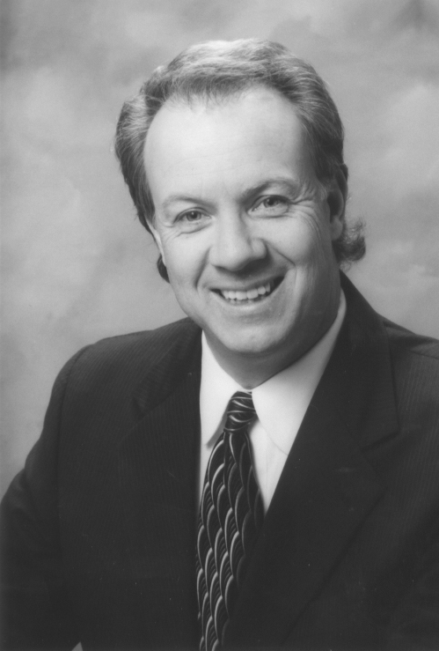
Are you sure the individuals you talk to every day, whether it is a customer, an employee, a peer, or your significant other are actually receiving the message you are sending? Are you ever surprised to find later that everything you’ve said has been not only misunderstood, but also misinterpreted? Mark will prove to us that even though we may not be aware of it, this is happening to us everyday. The question is, how can we make it better? Mark is ready, willing, and able to help by teaching us to “Stop Talking, and Start Communicating.”
Mark will teach you to “get good fast” in every business, networking and social opportunity:

- Discover your own personal, strong connections - chances you’re not using them.
- Stop using weak and ineffective phrases - your favorite crutches may be ruining your connections.
- Walk away with new skills: Mark instantly develops customized role-plays and online coaching for every audience

Mark’s been a student of winning communication skills for 25-years. He founded and ran a multi-million dollar video and live event production company in Tampa, Florida and has been a television reporter and anchor in Colorado, Florida, Minnesota and Arkansas. Mark has an undergraduate degree from UCLA in political science and a Master’s Degree in broadcast journalism from Northwestern University.
Please join us for an outstanding presentation and an evening of networking with your peers. Our evening will begin with a social and dinner, followed immediately by our speaker.
Date: | Wednesday, January 14, 2004
Location: | Radisson Hotel, 20967 U.S. Hwy 19 N., Clearwater, FL (see map)
Time: | 6:00 pm Social, Dinner served at 7:00 pm
Menu: | Dinner Salad, Chicken Chardonnay, Chef’s selection of steamed vegetables, potato, dinner rolls w/ butter, Chef’s Surprise dessert, and coffee or tea
Price: | Members and guests $18.00 per person, includes tax and gratuity. Student Members $9.00
Reservations and cancellations are required by noon on Monday, January 12, 2003. Reservations may now be made online at www.weiquality.com/asme . For those who do not have internet access, please call Helen Prince at 727-734-5546. All checks should be made payable to ASME-FWCS and mailed to Helen Prince, 1515 Ruth Road, Dunedin, FL 34698-4416. All ASME dinner meetings are open to the general public. Please make your reservation before sending your check. If you make a reservation & do not cancel by noon January 12, you will be billed.
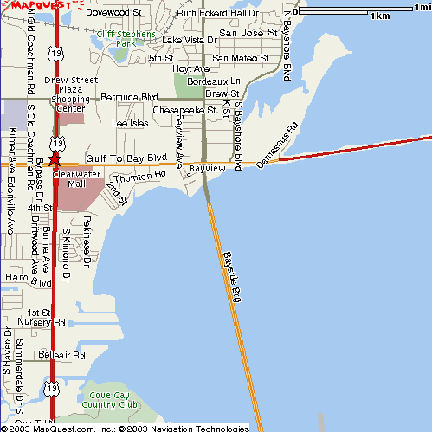
Bayside Bridge (49th Street) from St. Pete
Radisson Hotel
Courtney Cambell Causeway (From Tampa)
U.S. Hwy 19

Directions: The hotel is located on the north-bound service road that runs parallel to U.S. 19, north of Gulf-to-Bay Blvd. From Tampa, take Courtney Cambell Causeway west to Clearwater. Turn right on U.S.19, keep right to stay on the service road (U.S. 19 merges to the left). Radisson will be on your right. Coming from the south on U.S. 19, get off at Gulf-to-Bay exit and go straight through light at Gulf-to-Bay. Stay right and the hotel will be on your right.

RECAP OF NOVEMBER MEETING: Mr. Frank Dlouhy

On Wednesday, November 19th, Mr. Frank Dlouhy of Omega Power Systems, treated nearly 40 members of the FWCS’s of ASME and IEEE to an outstanding presentation. This intense look into the impact of lightning and electrical surge in the “Lightning Capital of the World” was both enlightening and sobering. The resounding message presented by Mr. Dlouhy was that surge suppression cannot be over emphasized when designing, or refurbishing, your facilities and equipment. Mr. Dlouhy’s presentation was actually an abbreviated version of his half-day seminars that he conducts throughout the southeast. Any ASME members who are interested in this more comprehensive look at the importance of surge suppression can contact Mr. Dlouhy at Omega Power Systems, (561) 997-0663.

CELEBRATE ENGINEERING 2004!

YOU ARE INVITED TO AN EVENING OF ENJOYMENT

WITH COLLEAGUES AND SPOUSES!

VENUE (Mark your calendar today)!
Date: Friday, February 13, 2004
Time: Social, Registration: 5:30 – 7:00 pm Dinner, events: 7:00 – 10 pm
Place: A LA CARTE EVENT PAVILION, Dana Shores Road, West of Tampa Airport. Check
their website for directions and pictures of elegance! http://www.alacarteeventpavilion.com/
Cost: $25 per person (What a bargain – subsidized by your Society!)
Reservations must be made in advance for planning purposes – no reservations taken at the door!
Contact John Conrad at 813-926-4004 for tickets or reserve online at: http://weiquality.com/celebrate2004
Credit cards are accepted!

Join us for the LARGEST GATHERING of engineering professionals, companions and guests on the West Coast of Florida! Don’t miss it, or you’ll have to wait another year!

A JOINT EFFORT BY SIX ENGINEERING SOCIETIES!
Six renowned engineering societies in the Tampa Bay area joined forces to promote engineering awareness within our own societies and the local community, in conjunction with the promotion of National Engineers Week, co-sponsored by your society and many other engineering societies during early February, in honor of George Washington’s Birthday.

AWARDS TO ENGINEERING HEROES AND OUTSTANDING TEACHERS!
Each society will recognize outstanding officers and members for their contributions and accomplishments in the engineering community and profession, for engineering and technical achievement. The Kim Lignell awards will be presented to 3 outstanding science/math/physics high school teachers from Hillsborough, Pinellas and Pasco Counties. These teachers are outstanding examples of high quality education for our future engineers and scientists.

ENTERTAINMENT!
A complement of entertainment will enhance your enjoyment of the evening! Start out with a musical serenade by local musicians to put you in the mood throughout the evening. Wander over to the caricaturist, to have your face emblazoned on canvas in a silly pose! A locally renowned personality will be our MC for the evening! He will not only pace the meeting, but keep us all in stitches with his stories and anecdotes, plus hand out many DOOR PRIZES!

GUEST SPEAKER!
Our Keynote Event will be a presentation by Dr. Robin Murphy, Director, USF Center for Robot-Assisted Search & Rescue! A video and robot demonstrations will be highlights of the evening. Don’t miss this presentation! You can find out more about Dr Murphy’s accomplishments at her website http://www.csee.usf.edu/~murphy/

SPONSORS/VENDORS!
A number of vendors and sponsors have again graciously agreed to support our Celebrate Engineering Banquet. Because of their generous support, the Committee is able to provide this elegant event to our members at a significant discount. Many vendors will have tables set up at the banquet featuring their engineering services & products. We encourage all attendees to visit their exhibits and thank sponsors personally for helping to support your Celebrate Engineering Banquet. New vendors/sponsors who would like to participate in our wonderful venue should contact Richard Beatie at r.beatie@ieee.org, Al Kurzenhauser at 813-251-6403, or John Chevalier at ChevalierEngCon@aol.com. All contributions are tax deductible!

DON’T DELAY - RESERVE NOW
WE WANT TO SEE YOU THERE!

A MESSAGE FROM THE FWCS CHAIR

The New Year has begun and our programs so far have been quite successful. The Holiday social, held December 10th at Malio’s Steak House in Tampa, was a lot of fun for me. I had the opportunity to present Earl Bage, a new FWCS member, with a distinguished service award for service as the Missouri State Government Coordinator. Giving awards is one of the perks the chair gets to enjoy. The evening was relaxed and presented time to get to know each other, which is difficult at our business and technical program meetings. The dinner conversations were diverse and generally unrelated to engineering.

February 13 will be the engineer’s week celebration banquet. The banquet is an intersociety function featuring great food and fascinating speakers. Each year it gets bigger and better, and last year’s presented an exciting program. Please see Page 3 of this newsletter for a full description of the Celebrate Engineering 2004 Banquet. I’m hoping to see you there!

Please keep in mind our program year is not yet half complete. We are preparing dinner meetings and tours through June. Also the student design contest and regional administrative conference are not far off.

Next month you will receive a ballot in your newsletter for next year’s officers. Once the new officers are confirmed the chair will begin looking for next year’s committee members. This presents opportunities for anyone interested in becoming more involved. The incoming chair will try to have the committee set by May and will begin taking charge during June with July 1 beginning the 2004-2005 program year.

In Service
Carl Riddlemoser
Chair ASME FWCS

_________________________________________________________________________________________

A WORD FROM THE EDITOR

As 2003 draws to a close, and 2004 is just beginning, now is the perfect time for reflection on what has happened, and for making plans and resolutions for the New Year. Last year was a trying one in many ways, but 2004 has the promise to be better, with the economy improving, and the Iraq situation being hopefully resolved soon, now that Saddam has been captured. Let us each resolve to do whatever we can to make 2004 the best year so far in the twenty-first century.

I have enjoyed my first five months as editor of this publication, and want to thank the FWCS membership
for taking the time to read it, the FWCS Executive Board for their input, and the sponsors for their support. Please take a moment to review the sponsors’ ads on Page 5, and see if you can send them some business
in the New Year.

I wish you all a Happy, Healthy, and Prosperous New Year!

John R. Chevalier, PE
ASME FWCS Newsletter Editor

Last Call for “Engineer of the Year” Nominations!!!

Now is the time to get serious about selecting our FWCS “Engineer of the Year.” We need your input to identify and nominate qualified Mechanical Engineers for “Engineer of the Year” for 2003. (To be announced at the Celebrate Engineering Banquet on February 13, 2004) Please contact Bill Adkins at (727) 539-4702 (billy.adkins@honeywell.com) with your recommendations for “Engineer of the Year” and help in generating a nomination for your candidate. We need our members input to make this a meaningful award.

We thank these sponsors for supporting engineering educational activities with
High School and University of South Florida Students:

REMEMBER! Keep your address information up-to-date!
Did you know that newsletters with incorrect addresses cause delays, cost extra postage for your Section, and extra work for volunteers, who must correct addresses and re-mail newsletters? To update your contact information please call Helen Prince at 727-734-5546.

Please note that the February Newsletter Deadline is:

Thursday, January 8, 2004
If you would like to submit a newsletter item to be published in our February newsletter, please call John
Chevalier at (727) 781-2682 or e-mail at ChevalierEngCon@aol.com by January 8, 2004. We would love to insert your story, event, job opportunity, or job wanted item in the newsletter.

FLORIDA WEST COAST SECTION OFFICERS FOR 2003-2004
CHAIR | VICE CHAIR | VICE CHAIR – PROGRAMS | TREASURER | SECRETARY
Carl Riddlemoser  ATC Assoc., Inc.  5801 Benjamin CTR Dr.  Suite 101, Tampa 33634  (813) 889-8960 ext. 245 | Stephen Elting  ABC Packaging Co.  811 Live Oak Dr.  Tarpon Springs, FL 34689-4199  (813) 966-3667 | Paul D. Stevenson  McCormick Stevenson Corp.  435 Causeway Blvd.  Dunedin, FL 34698  (727) 735-9633 | Robert W. Andrew  Hudson Pump & Equipment  3524 Craftsman Blvd.  Lakeland, FL 33803  (863) 665-7867 | Robert F.  Visbisky, P.E. Retired  (813) 968-9382
FLORIDA WEST COAST SECTION EXECUTIVE BOARD MEMBERS FOR 2003-2004
William P. Adkins, PE  (727) 539-4702 | Al Kurzenhauser  (813) 251-6403 | John Mulvihill  (813) 749-1134 | Aimee Taylor  (727) 669-3780 | Dr. Shuh-Jing “Ben” Ying, PE (813) 286-1904
Noel McCormick  (727) 735-9633 | Dr. Ronald L. Mann  (727) 938-1645 | Helen Prince  (727) 734-5546 | Bill Tarver  (727) 539-4307
Adam D. Mainzer  (813) 221-1222 | Dr. R. Gerry Miller, PE  (727) 397-6807 | Clarence Prince, PE  (727) 734-5546 | Chester J. Ugan  (727) 527-8191
Richard O. Fraze  (727) 522-6759 | Tim Hunt, PE  (727) 734-0026 | John R. Chevalier, PE  (727) 781-2682 | Neville G.P. Brass  (727) 397-2737

Non-profit org.
U.S. Postage
PAID
Tampa, Florida
Permit No. 1610
 | Florida West Coast Section  1515 Ruth Road  Dunedin, FL 34698 | Address Service Requested

