ASME NEWS & VIEWS  Published monthly except July & August  A.S.M.E. Florida West Coast Section  1515 Ruth Road  Dunedin, FL 34698 | 
January 2003, Volume 7 Issue 5

Raytheon Environmental Test Facility Tour
January 15, 2003

Please join us for a wonderful Chinese dinner, followed by an interesting and informative tour of the Raytheon Environmental Test Facility (NOTE – The tour is limited to US Citizens only. However, EVERYONE is welcome to join us for dinner!). This lab is responsible for Vibration, Shock, Thermal, Atmospheric and EMI testing of state-of-the-art US Military communications equipment, and is available for contract testing. Possibly your company could benefit from locally available testing services? Don’t miss this rare opportunity to visit this outstanding facility. We look forward to seeing you there!

Date: | Wednesday, January 15, 2003
Location: | Dinner: | Zom Hee Restaurant  Park Place Center, 9015 Park Blvd., Seminole  1½ Blocks West of Starkey Rd.  727.391.8393
 | Tour: | Raytheon Network Centric Systems  1501 72nd Street N., St. Petersburg
Time: | Dinner is scheduled between 6:00 - 6:30 p.m., followed by a short drive to the nearby Raytheon Facility for our guided tour at 7:30.
Menu: | 7-Dish Chinese dinner. Select from among several favorite Chinese dishes: Moo Goo Gai Pan, Sweet & Sour Chicken, Chicken Broccoli, Sautéed Mixed Vegetables, Sin Goo Shrimp, Pork Chop Suey. Includes Soup, Fried/Steamed Rice, dessert (Sherbet, Rice Pudding, Jell-O) and hot tea.
Price: | Members and guests, $18.00 per person, includes tax and gratuity. ASME student members $9.00.
NOTE! | THIS TOUR IS LIMITED TO US CITIZENS ONLY
Reservations: | Reservations and cancellations are required by noon on Friday, Jan 10, 2003. To make reservations, call Helen Prince at 727-734-5546. Make your checks payable to ASME-FWCS and mail to Helen Prince, 1515 Ruth Road, Dunedin, FL 34698-4416. All ASME dinner meetings are open to the general public, however this tour is limited to US Citizens only. Please call BEFORE sending your check. If you make a reservation & do not cancel by noon, Jan 10, you will be billed.

 |  | 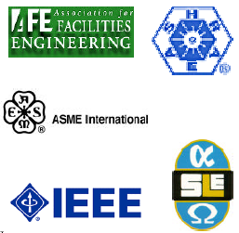
CELEBRATE ENGINEERS’ BANQUET 2003
“The Best Engineer’s Banquet Yet!”
WHEN: | FRIDAY, FEBRUARY 7, 2003
TIME: | 5:30 PM RECEPTION, 7 PM DINNER, 8:15 PM PROGRAM
LOCATION: | A LA CARTE ENGINEERING PAVILION, 4050 Dana Dr., Tampa FL 33634, (Off Memorial Dr. West of Tampa Airport), Tel: 813- 381-5390
TALK: | Engineering Development of International Space Station, by NASA
EMCEE: | Dick Crippen, TV Personality, Executive Director, Rays of Hope Foundation
AWARDS: | Engineer/ Technician of Year, Math -Science Teachers of Year and USF Student Engineers of the Year
ENTERTAINMENT: | Caricaturist, Magician and Musicians
DOOR PRIZES: | To Owners of Lucky Banquet Tickets

Engrave your new 2003 Calendars NOW: (Friday, February 7, 2003) and attend the Third CELEBRATE ENGINEERING BANQUET. This very elegant venue (Formerly Egypt Temple Shrine) can be viewed on the website: www.alacarteeventpavilion.com
We have increased the splendor of the Banquet through this upscale site.

The five-society Banquet Committee Team has been working diligently for six months to ensure another great and memorable evening, one that will provide the ambience of professional awards with a memorable evening. Awards will be presented to outstanding engineers, technicians, and student engineers. In addition to engineering awards, one award will be conferred on an outstanding mathematics or science high school teacher in each of Pasco, Pinellas and Hillsborough counties.

We are thankful for the financial support of prominent and farsighted engineering firms and vendors in industry. Their help has made it possible for us to provide for the prestigious awards and for you to attend. If your company wishes to be recognized for supporting this outreach to the profession, PLEASE contact Chair, Al Kurzenhauser at 813-251-6403. Don’t be a mushroom; help enlarge the profession’s influence as well as that of our industries (and. vice versa).

Ticket prices have been audaciously set low by the five-society committee-- at $40 per couple and $25 for one ticket. Purchases of tickets can be made direct to: Treasurer, Bob Andrew, (863) 665-7867

December’s Meeting: FWCS Holiday Social
Celebrating the holidays with our FWCS ASME family & friends was a very memorable experience this year thanks to the planning and coordination efforts of former chair, Neville Brass. It was truly a wonderful way to celebrate the holidays in Florida with a delicious tropical meal and entertainment. During the social, a variety of items were available for bid to help raise money for this year’s student activities including a 2-night weekend stay for two at the beautiful Hyatt Regency Westshore and several other auction items! Thank you to Neville Brass for coordinating this event and thank you to those persons/companies who contributed auction items.

PE Exam Review Online Live
Here is a testimonial from a colleague who recently passed the PE exam.
“I used the PE Exam Review Online Live program last fall, and I also passed the PE exam. I would like to thank ASME for referring me to this course. I was happy with the way it was structured. It kept me on track with my studies, gave me insight into what to expect, and it gave me the confidence to take the test and pass.” Mark Corpron, PE, Minneapolis, MN

PE Exam Review Online Live starts on January 21, 2003 (registration deadline is January 14th) go to: http://www.asme.org/education/disted/peonlinelive.htm for more information
Ordering Information: Product No. ZCTE10
$790 ASME Member
$820 Non-Member
Free Demo: http://www.asme.org/education/disted/peonlinelive.htm#Demo
To Register: https://secure.asme.org/cei/peonlinelivereg.cfm

Maximize your training budget with In-Company Programs
Your company is unique, with particular strengths, markets and issues relating to your daily work environments. Our courses are tailored to address your specific needs. ASME In-Company Programs staff will work closely with you through pre-course assessment to determine your specific training requirements and experience levels of participants. Find out more at our website http://www.asme.org/education/incomp/incompany.htm or call Olga Lisica at 212-591-7843.

New for 2003! ASME Fundamentals of Engineering FE Exam Review OnLine
Ordering Information: Product No. ZFENBC
$395 ASME Member
$495 Non-Member
Starts February 10, 2003, Duration 10 weeks (April 14), Registration deadline February 3.Study on your schedule-24/7 and get answers from experienced FE instructors online. As with studying alone, the FE course can be taken any time. And like a live class, this online course offers interaction - via email and online discussion - with experienced FE prep instructors and others taking the course. Within this ten week course there are 12 modules covering the following topics: chemistry, computer, dynamics, electric circuits, engineering economics, ethics, fluid mechanics, material science, mathematics, mechanics of materials, statics and thermodynamics. In addition to these modules, there are practice questions similar to those that exam takers will have to tackle. The course requires a computer with Internet access and Microsoft Word and PowerPoint software.
To Register - https://secure.asme.org/peonline/fetogoregistration.cfm
Demo Online Class - (select "preview")
http://208.254.4.135/bin/common/course.pl?course_id=_3_1&frame=top
For more information on the web go to:
http://www.asme.org/education/disted/examprep.htm
For more information contact Thomas Kuehl, 212-591-8013 or mailto:kuehlt@asme.org

News Item from USF Magazine Fall 2002 – “Robots Tested as Lifelines”

Engineering Professor Robin Murphy and other researchers have successfully field-tested robots adapted with small medical sensors that can relay vital information about rescue victims from a disaster site. The findings suggest that robots can help rescuers confirm the state of a victim and care for those trapped deep within rubbles. This is considered the first major advance in rescue robot technology since Sept. 11.
Determining a victim’s life signs is a crucial first step in a rescue. According to Federal Emergency Management Agency statistics, rescuing a victim may take 10 rescuers up to 10 hours. Being able to determine if the victim is unconscious and breathing rather than dead can expedite rescue efforts by allowing rescuers to focus first on victims who could be saved. Before now, a trained rescuer had to watch the view from the robot and try to guess whether a person was dead or alive. But Murphy’s sensors were effective in determining whether the victim was breathing by measuring exhaled carbon dioxide. The robot-based sensor was able to clearly detect breathing several feet away.
“Within 18 months we could have a whole suite of sensors under $500 that could provide quick, accurate assessments of disaster victims,” Murphy said.
In a collapsed building, maintenance of the victim while rescue teams are attempting to excavate them is difficult, and water is a critical component in their survival. In one of the trials, a robot was able to deliver fluids to a human via flexible tubing.
“This is a particularly exciting development, because it provides us a mechanism to deliver air, water or medications to a victim, and that’s a potentially life-saving intervention,” Murphy said. Murphy is the director of the Center for Robot-Assisted Search and Rescue (CRASAR) at USF. After hearing about the attacks on New York and Washington, D.C., Murphy and her graduate students took six urban search and rescue robots to the site of the World Trade Center attacks.
Her recent field trials used the same type of robots deployed at the World Trade Center to carry the sensors. These robots could be invaluable in chemical and biological disasters as well. Rescue teams must wear bulky protective gear in chemical disasters, preventing them from checking a pulse or other vital signs.
The Office of Naval Research through a subcontract to CRASAR sponsored the research. It is expected this technology could become available to emergency responders, police, and the military by Spring 2004.

Professional Practice Curriculum Development Continues
At its November meeting, the Board of Directors of the ASME Foundation continued its support for the development of the ASME Professional Practice Curriculum of approximately 40 free, on-line learning modules that will assist faculty in preparing engineering students to begin professional practice.
To learn more about the content of the PPC and its development, see a PowerPoint presentation:
http://www.asme.org/education/prodev/profpractice/update11-02.htm
Feedback is welcome! You are invited to visit the PPC website and give feedback on the Project Management and Product Life-Cycle Management series of modules that are now undergoing beta testing.
Go to: http://www.asme.org/education/prodev/profpractice
For more information on the Professional Practice Curriculum, contact Thomas Perry, Director of Education Services, at mailto:PerryT@asme.org
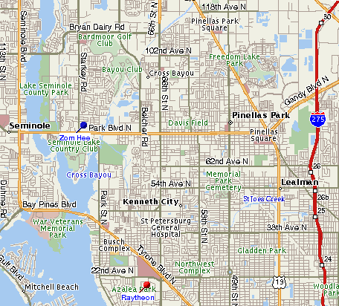
We thank these sponsors for supporting engineering educational activities with High School and University of South Florida Students:
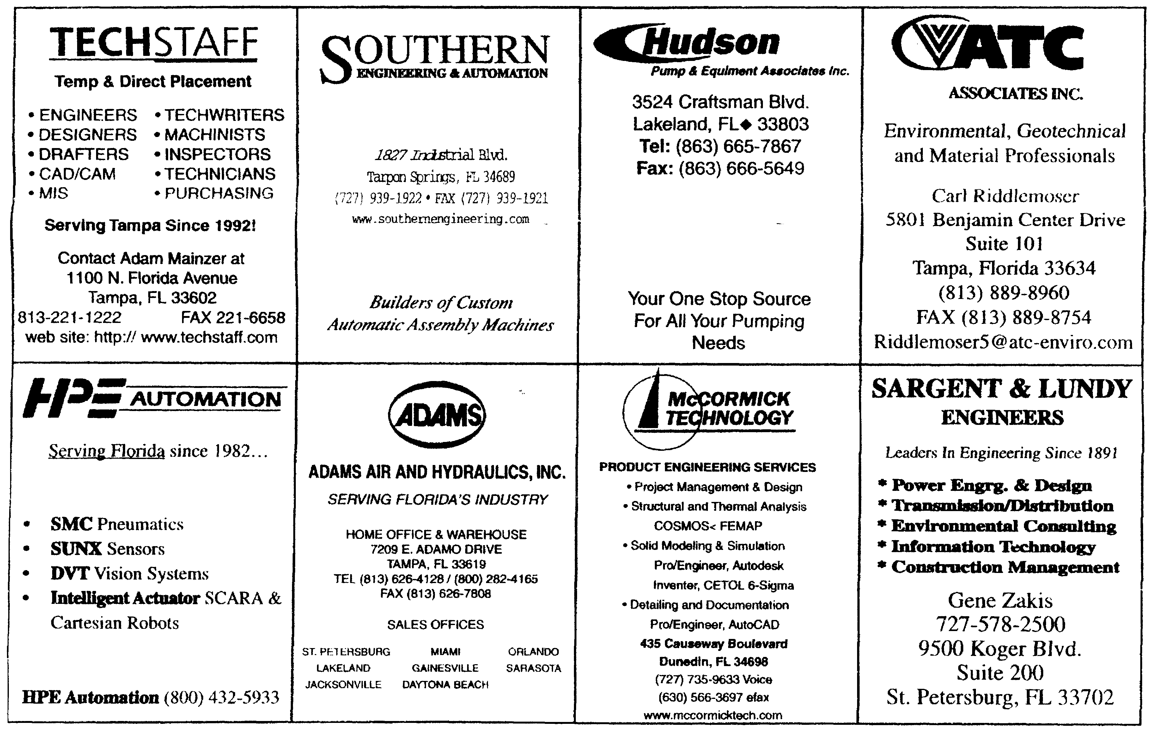

Keep Your Address Information
Up-to-Date!
Did you know that newsletters with incorrect addresses cause delays, cost extra postage for your Section, and extra work for volunteers, who must correct addresses and re-mail newsletters? To update your contact information please call Helen Prince at 727-734-5546.

FLORIDA WEST COAST SECTION OFFICERS FOR 2002-2003
CHAIR | VICE CHAIR | VICE CHAIR – PROGRAMS | TREASURER | SECRETARY
Michael Colitz, III  Holland & Knight LLP  400 N. Ashley Drive.  Tampa, FL 33602  (813) 227-6598  Fax: (813) 229-0134 | Carl Riddlemoser  ATC Assoc., Inc.  5801 Benjamin CTR Dr.  Suite 101, Tampa 33634  (813) 932-8960 ext. 245 | Stephen Elting  ABC Packaging Co.  811 Live Oak Dr.  Tarpon Springs, FL 34689-4199  (727) 937-5144 | Robert W. Andrew  Hudson Pump & Equipment  3524 Craftsman Blvd.  Lakeland, FL 33803  (863) 665-7867 | Robert F. Visbisky, PE  (813) 968-9382
FLORIDA WEST COAST SECTION EXECUTIVE BOARD MEMBERS FOR 2002-2003
William P. Adkins, PE  (727) 539-4702 | Al Kurzenhauser  (813) 251-6403 | John Mulvihill  (813) 749-1134 | Dr. Robert Pennington, II  (727) 345-6885 | Aimee Taylor  (941) 756-2594
Noel McCormick  (727) 735-9633 | Dr. Ronald L. Mann  (727) 938-1645 | Helen Prince  (727) 734-5546 | Bill Tarver  (727) 539-4307 | Richard O. Fraze  (727) 522-6759
Paul Stevenson  (727) 735-9633 | Dr. R. Gerry Miller, PE  (727) 397-6807 | Clarence Prince, PE  (727) 734-5546 | Chester J. Ugan  (727) 527-8191
Adam D. Mainzer  (813) 221-1222 | Tim Hunt, PE  (727) 734-0026 | Adam Jenkins  (727) 345-7085 | Neville G.P. Brass  (727) 397-2737

Non-profit org.
U.S. Postage
PAID
Tampa, Florida
Permit No. 1610
 | Florida West Coast Section  1515 Ruth Road  Dunedin, FL 34698 | Address Service Requested

