
April 2002, Volume 6 Issue 8
ASME NEWS & VIEWS
Published monthly except July & August
A.S.M.E. Florida West Coast Section
1515 Ruth Road
Dunedin, FL 34698
Indy Racing and the Effect of Aerodynamics on the Car
April 17, 2002

Mr. Arthur W. Ebeling has compiled information on Indy cars for nearly a half-century, covering development and changes to the sport. Currently retired and Midwest Director Emeritus, Mr. Ebeling has been involved at various levels in racing. This spans from professional to student competition. It has been very rewarding to see some of the results from changes implemented.

The history of Indy racing from 1911:

- Marmon Wasp roadster, front wheel drive, side winder, rear engine mount, gas turbine, wings front and back, ground effects, pods on each side of cockpit, tire changes, frontal area reduction, engine changes, turbo-charging, non turbo charging and safety concerns.
- The suspension problems relating to set-up as well as changes in driving patterns.
- Wind tunnel testing as related to wings and tires.

Mr. Arthur W. Ebeling holds a B.S. from Rose Hulman Institute of Technology and has very broad experience in industry, chemical, steel, foundry and special metals. Holder of several patent rights in the controlled pressure pouring area, he is an ASME Fellow and has served in various capacities in a number of ASME units. His latest position was Midwest Director, a position he held for 18 years.

Date: Wednesday, April 17, 2002

Location: Radisson Bay Harbor Hotel

Time: Social from 6–7 PM, Dinner starts at 7PM, followed by the program

Menu: Chicken Monterey with Garden Salad, Vegetable DeJour, Rolls, Parsley Potatoes, Coffee or Tea, Key Lime Pie

Price: Members, and Guests $18.00 per person, includes tax and gratuity
ASME Students: $9.00

Reservations: Reservations and cancellations are required by noon on Monday, April 15, 2002. To make reservations, call Helen Prince at 727-734-5546. Make your checks payable to: ASME-FWCS, and mail to Helen Prince, 1515 Ruth Road, Dunedin, FL 34698. All ASME dinner meetings are open to the general public. Please call BEFORE sending check. If you make a reservation & do not cancel by April 15th, you will be billed.

Student Papers Night
We thank Dr Ron Mann and the USF Student Section for hosting a great meeting on March 27th. For those who missed the meeting, you missed a great opportunity to see some of the projects students are currently working on. We thank Michael Jurczyk and Nicholas Snapp for their outstanding presentations and wish them well as they compete in the ASME Old Guard Competition at the Regional Student Conference in Jackson Mississippi April 5th & 6th.

Get active in your local section activities.

Congratulations to our New Officers
Mike Colitz – Chair, Carl Riddlemoser – Vice Chair, Steve Elting – Vice Chair Programs, Bob Visbisky – Secretary, Bob Andrew – Treasurer

FWC section board meetings are held in the evening, monthly at Mustang Engineering, Tampa Office on Lois Avenue; all members are welcome and encouraged to attend. For more information, times, and dates, contact one of the officers listed above, or send an e-mail to andrewr@asme.org.

Upcoming Events

May 8th Meeting – Tampa Bay Estuary Restoration
Ms. Holly Green will present an informative program on the cutting edge restoration efforts currently underway to restore water quality in Tampa Bay. Location – TBD

June 12th Meeting – Honors and Awards
FWC Section’s year-end meeting. Awards to local section volunteers, Speaker on Overhead Rail System – Location Radisson Bay Harbor Inn

Planning for the Future
The FWC section board is currently looking for ideas and locations for the 2002 – 2003 dinner meetings. If you have a topic, tour idea, or suggestions for meetings, please contact Steve Elting at (813) 831-7286 or selting@abcpackaging.com.

Influence the Future of Engineering – Become a Mentor!
It’s easy to sign up. Just go to www.asme.org/ementoring and click on “Become a Mentor.”
For more information about mentoring, or to view the mentor already online, please visit www.asme.org/ementoring or contact Deidra Hackley, coordinator, student programs at hackleyd@asme.org or 212-591-7852.

ASME Florida West Coast Dinner Meeting Payment and Cancellation Policy: In an effort to maintain the affordability of our monthly dinner meeting, The FWC Executive committee has established the following policy on Dinner meeting. If a member, student member, or guest makes a reservation and does not cancel by the reservation deadline, resulting in the local section incurring a charge for that dinner, the member, student member, or guest will be billed for the cost of the dinner incurred by the section. We will strive to hold our dinner meetings at locations that will be affordable to our membership, and whenever possible to utilize restaurants or locations where we will not incur charges for a missed cancellations. We understand that occasionally unforeseen circumstances may arise, and in these occasions, the executive board will review the information and decide if the member, student member, or guest will be responsible for the dinner cost incurred.

Florida West Coast Section

Professional Development Opportunities

Fundamentals of Geometric Dimensioning & Tolerancing (GD&T)
The Application of ASME Y14.5M – 1994

This one-day interactive training experience presents the fundamentals of applying and interpreting the internationally recognized standard for dimensioning and tolerancing of engineering drawings.

The proper application and interpretation of GD&T enables engineering, manufacturing and quality technologists to reduce manufacturing costs as they exercise these proficiencies:

- Prepare/revise GD&T drawing definitions based on functional design requirements and critical design features.
- Develop processes, tooling and acceptance procedures based on features and requirements most critical to proper form/fit/function.
- Employ dimensioning and tolerancing techniques that maximize manufacturing tolerances while ensuring that functional design requirements are met.
- Analyze problems with existing GD&T drawing definitions and develop optimum solutions.

This class is recommended for those with proficient blueprint reading skills and some exposure to GD&T concepts.

Instructor: Mr. Don Patz
President
Patz Technical Services
Seminole, FL

Location: TECO Energy Technology
Resource Center (ETRC)
3650 Spectrum Blvd., Suite 100
Tampa, Florida 33612
Map available at “www.etrc.com”

Date & Time: Saturday, April 27, 2002, 8am – 4pm

Cost: ASME Member $100.00
Non-Member $150.00
Student $ 65.00

Registration: Please complete the enclosed “Seminar Registration Form” and submit to the address provided.

Information: For any questions regarding course content, scheduling, reservations or payment terms, please contact:

Noel McCormick
FWCS Professional Development Chairman
noel@mccormicktech.com (e-mail is preferred)
(727) 735-9633

Florida West Coast Section | 

Seminar Registration Form

Name
Company
Mailing Address
Telephone (Day) | ( )
Fax | ( )
Email

Please register me for the following course:

_____ | Geometric Dimensioning & Tolerancing April 27, 2002  8am – 4pm | Registration Fee:  ASME Member $ 100.00  Non-Member $ 150.00  Student $ 65.00

Registration Deadline: April 15, 2002

Total Amount Enclosed: ________________

Make check payable to: ASME Florida West Coast Section

Mail check to: ASME Southern Regional Office

Attn: FWCS Seminar
1950 Stemmons Freeway, Suite 5068
Dallas, TX 75207

Please send check or money order with registration form. Sorry, no credit cards or purchase orders.

Want to change the way ASME works,
Or propose a new Idea?
The Member Initiative System permits any member or operating unit of ASME to propose improvements to Society policy or procedure or to make any other suggestions related to the operation or activities of the Society.
The Member Initiative System provides a way to bring the thoughts of the members to the attention of various operating units of the Society and the Board of Governors.
The Member Initiative System provides a means for:
A. Solicitation and collection of initiatives;
B. Review and selection of Initiatives in order to present to the Board of Governors those items which receive significant support by delegates representing the membership of the Society; and
C. Review and reporting of the status of those Initiatives presented to the Board of Governors or assigned to various operating units of the Society for study and action.
For more information, forms, etc. see
http://www.asme.org/cma/bmi

NEW ASME MEMBERS NEEDED!! (And there is a “Free Lunch” for New FWCS ASME Members, see below)
The Florida West Coast Section is working hard to meet it’s “Membership” Goal for recruiting New Members before the end of our Program year (June 30). In order to meet our Section’s MDC (Membership Development Committee) goals and have a successful program year, we need each FWCS member’s help in reaching our ‘01-‘ 02” New Member quota of 48.
We need “New Member” participation and ideas to help keep our Section programs active and viable, so I’m asking each FWCS member to recruit one of their friends, colleagues or associates to join us as a member of ASME. Tell your engineering friends and co-workers of the value of being an ASME member and help them fill out an application to join.
Also FWCS treats all new members to a free meal at their first Section meeting (that’s where the “Free Lunch” comes in). Plus there are monetary awards and prizes from Region XI and ASME International for top recruiters in each Section (so our members benefit from promoting ASME as well as the Section). Get in the spirit of promoting your Professional Society and help us reach our MDC goals. For more info on MDC activities & opportunities (or if you need Membership applications) call Bill Adkins at 539-4702, or you can find an application on ASME’s Website under “Membership”.

2001-2002 Member-Get-A-Member Campaign
Help ASME International serve the needs of the mechanical engineering community by sponsoring new members. With each new member, you recruit, 50 percent of the first year’s dues will be spent on scholarships for mechanical engineering students.
For complete program details, log onto http://www.asme.org/membershipdrive

We thank these sponsors for supporting engineering educational activities with High School and University of South Florida Students:

MAP TO Radisson
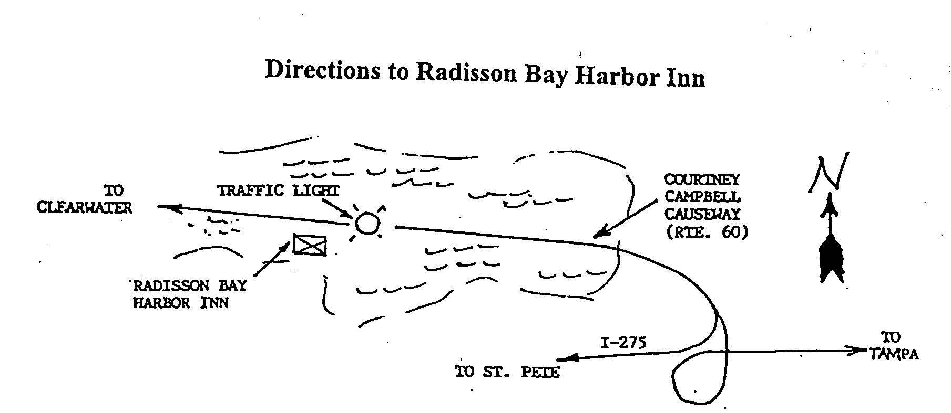
Keep Your Address Information
Up-to-Date Online!
Did you know that newsletters with incorrect addresses cause delays, cost extra postage for your Section, and extra work for volunteers, who must correct addresses and re-mail newsletters? To update your contact information please call Helen Prince at 727-734-5546.

ELECTRONIC AGE
If you would like to receive our newsletter via E-mail, please send your address to andrewr@asme.org and put newsletter in the subject line. All addresses will be kept confidential. For the latest information on ASME events, check out the Florida West Coast Section web page. http://www.bobandrew.com/asme We have links to many important and interesting sites for jobs, codes and standards, etc

FLORIDA WEST COAST SECTION OFFICERS FOR 2001-2002
CHAIR  Neville G. P. Brass  (727) 397-2737  12040 108th Ave. N  Largo, Fl  33778-3532 | VICE CHAIR  Michael J. Colitz, III  Holland & Knight LLP  400 N. Ashley Drive.  Tampa, FL 33602  813-227-6598  Newsletter Fax  813 229-0134 | VICECHAIR-PROGRAMS  Carl Riddlemoser  ATC Assoc., Inc.  5801 Benjamin CTR Dr. Suite 101, Tampa  FL 33634  813-889-8960 ext 245 |  | TREASURER  Tim Hunt, P.E.  Rhunts Engineering  568 Baywood Dr. N.  Dunedin, FL 34695  727-734-0026 |  | ACTING SECRETARY  Robert W. Andrew  Hudson Pump & Equipment  3524 Craftsman Blvd.  Lakeland, FL 33803  863-665-7867
FLORIDA WEST COAST SECTION EXECUTIVE BOARD MEMBERS FOR 2001-2002
William P. Adkins PE  727-539-4702  Noel McCormick  727-735-9633  Karen Vallar  727-595-6366 | Al Kurzenhauser  813-251-6403  Dr. Ronald L. Mann  727-938-1645  Dr R. Gerry Miller  727-397-6807 |  | John Mulvihill  813-855-4693 x23  Helen Prince  727-734-5546  Clarence Prince PE  727-734-5546 |  | Robert Pennington  813-974-8284  Bill Tarver  727-539-4307  Chester J. Ugan  727-527-8191 |  | Robert F. Visbisky PE  813-968-9382  Richard O. Fraze  727-522-6759  Stephen D. Elting  813-831-7286

