April 2000, Volume 5 Issue 8

Tour Peerless Fedco
Maker of Automated Bakery Equipment
Wednesday, April 11th

Fedco (a division of Peerless) is the leader in the manufacture of highly automated bakery equipment. Fedco specializes in automated depositors, coaters, injectors, conveyors and cooling tunnels. They have a large CNC machine shop, fabrication welding shop, and electrical panel build area. Most of the machinery is PLC controlled. Fedco’s engineering department uses ACAD and a Bill of Material process in its release to manufacturing. If you want a Ding Dong chocolate coated, or a Twinkie injected with cream, or nuts sprinkled on your cakes, and you need hundreds done in a minute you're probably going to need a Fedco Machine. Come see some of the innovations happening in this competitive industry at this informal gathering.

Where: Peerless/Fedco 1920 Gunn Highway, Odessa (see map on back page).

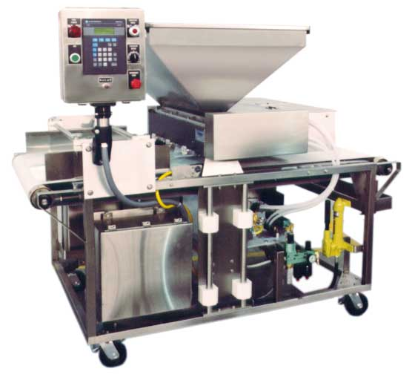
Dinner: Tournament Players Club, 5300 W. Lutz Lake Fern Road, Lutz FL 33549. Phone number: 813-949-0090 (see map on back page).

Cost: $15.00 per person. Buffet style ‘Country Style Bar-B-Que’ Potato Salad, Grilled Hamburgers, Hot Dogs and Chicken Breast, Baked Beans, Sliced Cheeses, Relish Tray, Assorted Breads, Condiments, Assorted Cookies, Coffee, Tea, Decaf. Cash Bar opens at 6:30, Dinner at 7:00, Short Fedco talk 7:45, drive 7 minutes, Tour begins at 8:15, leave Fedco 8:45.

Fedco's WPD Piston Depositor

Reservations and cancellations are required by Noon April 9th. To make reservations, call Helen Prince at 727-734-5546. Paying in advance by check would be appreciated. Make your check payable to ASME-FWCS and mail to Helen Prince, 1515 Ruth Road, Dunedin, FL 34698. All ASME dinner meetings are open to the general public.

UPCOMING FWCS EVENTS
May 9th -Publix DairyTour ; June 13th – Speaker on bio-med topic at Tampa Radisson Bay Harbor.

ASME Announces 2001 Fluids Engineering Conference
in New Orleans
ASME will hold the 2001 Fluids Engineering Conference from May 29-June 1 at the Sheraton Hotel in New Orleans, La. The Conference will include over 300 technical papers on computational fluid dynamics, measurement and control, fluid machinery finite element applications and other topics. The conference will also present an exhibition featuring products in demand by automotive, aerospace, biomedical and other industries around the world. For more information on the ASME Fluids Engineering Conference, call 800-843-2763, or visit the web site at www.asme.org/conf/fed01

Computer-Based Training from Professional Development
Learn how to use the Section VIII, Division 1 Code through this computer-based training program from ASME International Professional Development. This course is designed for you to study at your own pace and convenience. There are over 40 interactive exercises for you to solve on your own or follow the step-by-step logic of the experts. You can "take the course" as one continuous program or select the modules you need to review. When you successfully complete the post-test,you can earn 7 CEUs. The program was developed with Dr. Will Carter, lead subject matter expert who has served on many Section VIII Code Committees and reviewed by other Code Committee members. Check out the Demo on our site at: www.asme.org/pro_dev/section_vIII.html The price is $895 ASME member/$995 list. Contact Kathy J. Warner, Product Development Specialist, at 212-591-7411 or warnerk@asme.org for more info.

We thank these sponsors for supporting engineering educational activities with High School and University of South Florida Students:

USF Holds Student Papers Night
USF held its annual Student Papers Night on March 21th. Held at the Energy Technology Resource Center, the event allowed undergraduates to showcase their ongoing research projects as well as network with Bay Area engineers. Among the participants was Clay Rabens who gave a presentation on the performance and design of grated gutter inlets. Clay's design concentrated on Florida Department of Transportation's Index 220, Type S inlet. Additionally, Jean-Paul Deeb presented on the design of a collapsible surgical stretcher. Jean-Paul's design efforts were conducted at the request of James A. Haley Veteran's Hospital. Those in attendance were treated to a barbecue dinner. FWCS kindly thanks those students who participated, as well as Dr. Ronald L. Mann for planning the event.

Pass the PE Exam in 2001!

Was passing the PE Exam in April one of your goals for the new year? If so, ASME International – Professional Development can help you.

The PE Online review course was developed to assist engineers preparing for the second part of the licensing exam, The PE Exam: Principles and Practice of Mechanical Engineering. It
is available online and ready to help you achieve your goals.

For a demo and more information, please check log onto http://peonline.asme.org or call Kathy Warner at (212) 591-7411 (warnerk@asme.org)

Keep Your Address Information
Up-to-Date Online!

Did you know that newsletters with incorrect addresses cause delays, cost extra postage for your Section, and extra work for volunteers, who must correct addresses and
re-mail newsletters?

Did you know that you could update your ASME records online?

Just log onto: http://www.asmeny.org/memberaddr/html/security.htm and follow the easy instructions.

You can also call InfoCentral
at 800-843-2763


Now through June 30, 2001, receive an ASME Umbrella
when you recruit 2 or more paid New members.
Shower your colleagues with the benefits of
√ Mechanical Engineering Magazine
√ Latest Technical Information
√ Professional Development
√ Meetings, Conferences and Expositions
√ Auto and Homeowner Insurance and Group Insurance
√ Networking Opportunities
through ASME Membership.

Map to Tournament Players Club

ELECTRONIC AGE
If you would like to receive our newsletter via E-mail, please send your address to andrewr@asme.org and put newsletter in the subject line. All addresses will be kept confidential. For the latest information on ASME events, check out the Florida West Coast Section web page. http://www.bobandrew.com/asme We have links to many important and interesting sites for jobs, codes and standards, etc.

FLORIDA WEST COAST SECTION OFFICERS FOR 2000-2001
CHAIR  Neville G. P. Brass  (727) 397-2737  12040 108th Ave. N  Largo, Fl  33778-3532 | VICE CHAIR  Tim Hunt, P.E.  Rhunts Engineering  568 Baywood Dr. N.  Dunedin, FL 34695  727-734-0026 | VICECHAIR-PROGRAMS  Robert W. Andrew  Hudson Pump & Equipment  3524 Craftsman Blvd.  Lakeland, FL 33803  863-665-7867 |  | TREASURER  Karen Vallar  12800-7852 Vonn Rd.  Largo, FL 33774  727-595-6366 or |  | SECRETARY  Michael J. Colitz, III  Holland & Knight LLP  400 N. Ashley Drive.  Tampa, FL 33602  813-227-6598  Newsletter Fax  813 229-0134
FLORIDA WEST COAST SECTION EXECUTIVE BOARD MEMBERS FOR 2000-2001
William P. Adkins PE  727-539-4702  Gene Allen  727-588-0147  Katharine Speltz  813-269-9319 | Al Kurzenhauser  813-251-6403  Dr. Ronald L. Mann  727-938-1645  Dr R. Gerry Miller  727-397-6807  Justine Viera  813-978-1000 ext 158 |  | John Mulvihill  813-855-4693 x23  David L. Mustain  727-724-6624  Helen Prince  727-734-5546  Clarence Prince PE  727-734-5546 |  | Robert Pennington  813-974-8284  Carl Riddlemoser  813-932-7332  Bill Tarver  727-539-4307  Chester J. Ugan  727-527-8191 |  | Robert F. Visbisky PE  813-630-6998  James R. Windgassen  727-791-7599  Richard O. Fraze  727-522-6759  Stephen D. Elting  813-831-7286

TPA1 #1122026 v1

