ASME NEWS & VIEWS  Published monthly except July & August  A.S.M.E. Florida West Coast Section  1515 Ruth Road  Dunedin, FL 34698 | 
December 2003, Volume 8 Issue 4

FWCS Holiday Social
December 10, 2003

Join your FWCS ASME family & friends in celebrating the holidays at

Malio’s Steak House. – Please come and bring a friend!
Date: | Wednesday, December 10, 2003
Location: | Malio’s Steak House, 301 South Dale Mabry Highway, Tampa. (See map on next page)
Time: | Social Hour: 6:00 PM Dinner: 7:00 PM
Menu: | Choice of Entrée: |  | - Prime Filet  - Boneless Breast of Chicken  - Salmon Linguine with Scallops  * All entrées are served with bread, choice of garden or Caesar salad and vegetable of the day or potato.
 | Dessert: |  | Key Lime Pie, Peach Malio, Cheese Cake
 | Beverage: |  | Coffee, Unsweetened Tea, Cash Bar
Price: | Members and guests, $34.00 per person, includes tax and gratuity. ASME student members $17.00 per person.
NOTE! | Please advise choice of main course and dessert when making your reservations.
Reservations: | Reservations are limited to forty. Reservations and cancellations are required by noon on Monday, December 8, 2003. Reservations may now be made online at www.weiquality.com/asme. For those who do not have internet access, please call Helen Prince at 727-734-5546. All checks should be made payable to ASME-FWCS and mailed to Helen Prince, 1515 Ruth Road, Dunedin, FL 34698-4416. All ASME dinner meetings are open to the general public. Please make your reservation before sending your check. If you make a reservation and do not cancel by noon December 8 you will be billed.

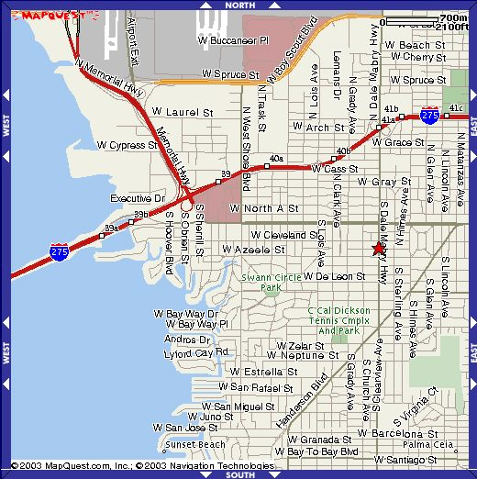
St. Petersburg
Clearwater
Malio’s Steak House
From St. Petersburg: Take I-275 north towards Tampa. Cross the Howard Franklin Bridge and continue eastward towards downtown Tampa. Exit at Dale Mabry (US 92), Southbound. The restaurant is located on the right hand side of Dale Mabry, 0.18 miles south of Kennedy Blvd, on the corner of Azeele Street and Dale Mabry.
From North Pinellas: Take Route 60 towards Tampa. Cross the Courtney-Campbell Causeway and continue on 60 as it passes the airport, and Westshore Mall. Route 60 becomes Kennedy Blvd. Take Kennedy Blvd to Dale Mabry and turn right, heading south. The restaurant will be 0.18 miles south on the right hand side, on the corner of Azeele and Dale Mabry.

ASME walks for American Heart Association
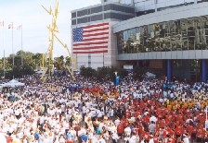
On November 1, 2003, a group of ASME members got together for the annual American Heart Walk. This was the first time ASME has participated, but Volunteer USF, a volunteer center on campus for student organizations and faculty members, has been doing it for 10 years. Dennis Watkins, James Pope, Julie Halsema and Bijal Chhadra met at 7:00am. With next to no sleep due to the homecoming game, the four walked 4 miles up and down Bayshore Blvd. More then 15,000 people participate in this event annually. We also met USF's president Dr. Judy Genshaft and took a group photo. As Activities Chair, I will plan many more community-related events like this one during the next 8 months.
Dennis Watkins
ASME Activities Chair,
USF Student Section

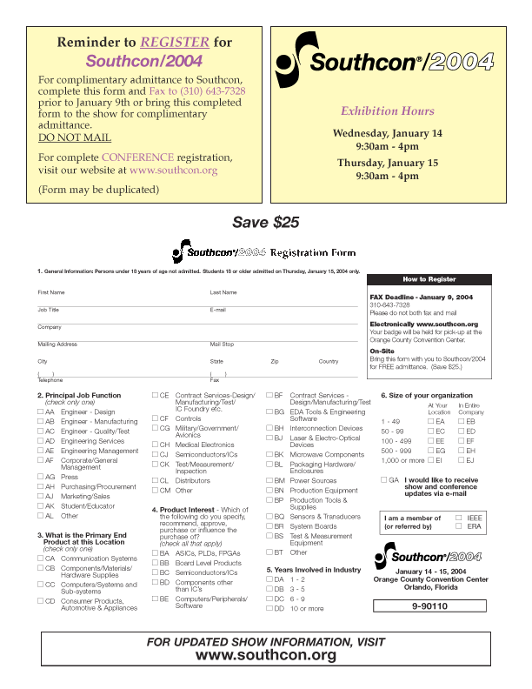

Complete Conference Information & Registration Form are available at www.southcon.org
Rev. 7/17/03
Southcon Exhibit Hours |  |  |  |  |  |  | 10-5 |  |  |  |  | 10-4
Day Planner |  |  | Tues.  1/13 |  |  |  |  | Weds.  1/14 |  |  |  | Thurs.  1/15
 |  |  | AM |  | PM |  |  | AM |  | PM |  | AM | PM
Southcon Conference Hours |  |  | 9-4 |  |  |  |  | 9-5 |  |  |  | 9-5
Keynote Luncheon (Noon to 2:00 pm)
K1 | What Lies Ahead for the Electronics Industry?, Susan Mulcahy, Vice President and Director of Research, Reed Electronics Group | $25
Special Events
SP1 | Workshop in a Box: An Introduction to Designing with PICmicros using the PICkit1 Starter Board | $50
SP2 | Take the Low Power Challenge: Develop Ultra Low-Power Embedded MCU Application | $50

Design and Manufacturing Tutorials (Lunch Included)
SC1 | Analog Electronic Design | $310
SC2 | Advanced Signal Conditioning Design | $310
SC3 | BGAs - Layout Techniques, Routing, PCB Stackups and Rework Issues | $310
SC4 | EMC Printed Circuit Board Design Practices | $310
SC5 | FPGA Design with VHDL - Basics for Design Engineers | $310
SC6 | FPGA Design with VHDL - Advanced Topics | $310
SC7 | FPGA Design with VHDL - Test Benches and Design Verification | $310
SC8 | Grounding, Bonding and Shielding | $310
SC9 | Opto-Electronic Design Considerations | $160
SC10 | Reflow and Wave Soldering with Emphasis on BGAs | $310
SC11 | Thermal Aspects of Electronics Cooling | $160
SC12 | Troubleshooting the SMT Manufacturing Line - Defect Causes & Solutions | $310

Conference Hours
Tues., Jan. 13 9 AM – 4 PM (9-Noon & 1-5 PM)
Weds., Jan. 14 9 AM – 5 PM (9-Noon & 2-5 PM)
Thurs., Jan. 15 9 AM – 5 PM (9-Noon & 2-5 PM)
CEUs will be awarded for all tutorials.

Register Early – Prices above are effective through December 23, 2003. Beginning on December 24, the cost of each course increases by $50.

Special Assistance - If you require special assistance covered under the Americans with Disabilities Act, please contact us at (310) 524.4100, Ext. 218 by December 24.

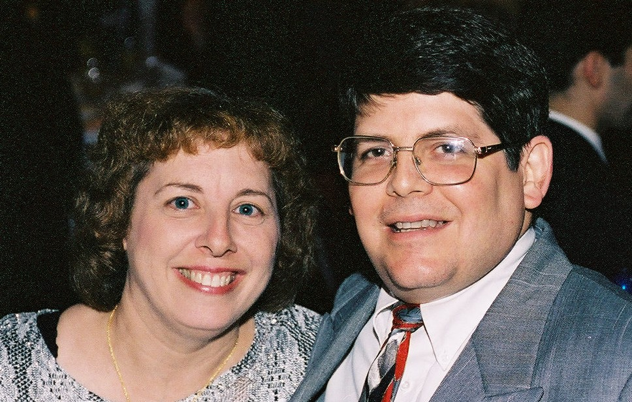

CELEBRATE ENGINEERING 2004!

YOU ARE INVITED!

Join us for the LARGEST GATHERING of engineering professionals, companions and guests! South from Naples, North to Inverness, East to Lakeland and Winter Haven!

If you attended one of the last three year’s Celebrate Engineering Banquets, like the happy couple above, you already know what an uplifting experience it was! If you haven’t attended one of our banquets yet, you don’t know the opportunities you have missed out on. Don’t let it happen again this year!

What is the Celebrate Engineering Banquet about? Five major engineering societies in the Tampa Bay area joined forces to promote engineering awareness within our own societies and the local community, in conjunction with the promotion of National Engineers Week, co-sponsored by your society and many other engineering societies during early February. Please join us for an unforgettable and festive evening of events and food planned specially for you and your companion/spouse.

AWARDS TO HEROS!
Each society will recognize outstanding officers and members for their contributions and accomplishments in the engineering community and profession, for engineering and technical achievement. Join us in congratulating them for their accomplishments!

Kim Lignell awards will be presented to 3 outstanding teachers. This award is given annually in memoriam to Mr. Lignell, an IEEE officer who dedicated his support to promoting engineering education in the schools, to a science/math/physics teacher from Hillsborough, Pinellas and Pasco Counties. These teachers are selected by vote from their peers, and are outstanding examples of the quality of education our future engineers and scientists are receiving in high school. Again, join us in congratulating them for a job well done, and offer your individual/corporate support to help them and their peers in their educational efforts!

ENTERTAINMENT!
For your most memorable experience of the year we have lined up a complement of entertainment to enhance your enjoyment of the evening! Start out with a musical serenade by local musicians to put you in the mood throughout the evening. Wander over to the caricaturist, to have your face emblazoned on canvas in a silly pose!

A locally renowned personality will be our MC for the evening! He will not only pace the meeting, but keep us all in stitches with his stories and anecdotes, plus hand out many DOOR PRIZES!

GUEST SPEAKER!
Our Keynote Event will be a presentation by Dr. Robin Murphy, Director, USF Center for Robot-Assisted Search & Rescue! A video and robot demonstrations will be highlights of the evening. Don’t miss this presentation! You can find out more about Dr Murphy’s accomplishments at her website http://www.csee.usf.edu/~murphy/

SPONSORS/VENDORS!
A number of vendors and sponsors have again graciously agreed to support our Celebrate Engineering Banquet. Because of their generous support, the Committee is able to provide this elegant event to our members at a significant discount (50%) over what it actually costs us to provide it to our members!

Many vendors will have tables set up at the banquet featuring their engineering services & products. We encourage all attendees to visit their exhibits and thank sponsors personally for helping to support your Celebrate Engineering Banquet. Without their dedicated support the Committee would not be able to provide you the elegance you will experience at such an affordable and reasonable cost!

New vendors/sponsors who would like to participate in our wonderful venue should contact Richard Beatie at r.beatie@ieee.org or John Chevalier at ChevalierEngCon@aol.com. All contributions are tax deductible!

VENUE (Mark your calendar today)!
Date: Friday, February 13, 2004
Time: Social, Registration: 5:30 – 7:00 pm; Dinner, events: 7:00 – 10 pm
Place: A LA CARTE EVENT PAVILION, Dana Shores Road, West of Tampa Airport Check their website for directions and pictures of elegance! http://www.alacarteeventpavilion.com/
Cost: $25 per person (What a bargain – subsidized by your Society!)
Reservations must be made in advance for planning purposes – no reservations taken at the door!
Contact John Conrad at 813-926-4004 for tickets or reserve online at: http://weiquality.com/celebrate2004
Credit cards are accepted!

DON’T DELAY - RESERVE NOW

WE WANT TO SEE YOU THERE!
“Engineer of the Year” Nominations Needed!

It’s time to start selecting our FWCS “Engineer of the Year.” We need your input to identify and nominate qualified Mechanical Engineers for “Engineer of the Year” for 2003. (To be announced at the Celebrate Engineering Banquet on February 13, 2004) Please contact Bill Adkins at (727) 539-4702 (billy.adkins@honeywell.com) with your recommendations for “Engineer of the Year” and help in generating a nomination for your candidate. We need our members input to make this a meaningful award.

We thank these sponsors for supporting engineering educational activities with
High School and University of South Florida Students:

REMEMBER! Keep your address information up-to-date!
Did you know that newsletters with incorrect addresses cause delays, cost extra postage for your Section, and extra work for volunteers, who must correct addresses and re-mail newsletters? To update your contact information please call Helen Prince at 727-734-5546.

Please note that the January Newsletter Deadline is:
Monday, December 8, 2003
If you would like to submit a newsletter item to be published in our January newsletter, please call John
Chevalier at (727) 781-2682 or e-mail at ChevalierEngCon@aol.com by December 8, 2003. We would love to insert your story, event, job opportunity, or job wanted item in the newsletter.

FLORIDA WEST COAST SECTION OFFICERS FOR 2003-2004
CHAIR | VICE CHAIR | VICE CHAIR – PROGRAMS | TREASURER | SECRETARY
Carl Riddlemoser  ATC Assoc., Inc.  5801 Benjamin CTR Dr.  Suite 101, Tampa 33634  (813) 889-8960 ext. 245 | Stephen Elting  ABC Packaging Co.  811 Live Oak Dr.  Tarpon Springs, FL 34689-4199  (813) 966-3667 | Paul D. Stevenson  McCormick Stevenson Corp.  435 Causeway Blvd.  Dunedin, FL 34698  (727) 735-9633 | Robert W. Andrew  Hudson Pump & Equipment  3524 Craftsman Blvd.  Lakeland, FL 33803  (863) 665-7867 | Robert F.  Visbisky, P.E. Retired  (813) 968-9382
FLORIDA WEST COAST SECTION EXECUTIVE BOARD MEMBERS FOR 2003-2004
William P. Adkins, PE  (727) 539-4702 | Al Kurzenhauser  (813) 251-6403 | John Mulvihill  (813) 749-1134 | Aimee Taylor  (727) 669-3780 | Dr. Shuh-Jing “Ben” Ying, PE (813) 286-1904
Noel McCormick  (727) 735-9633 | Dr. Ronald L. Mann  (727) 938-1645 | Helen Prince  (727) 734-5546 | Bill Tarver  (727) 539-4307
Adam D. Mainzer  (813) 221-1222 | Dr. R. Gerry Miller, PE  (727) 397-6807 | Clarence Prince, PE  (727) 734-5546 | Chester J. Ugan  (727) 527-8191
Richard O. Fraze  (727) 522-6759 | Tim Hunt, PE  (727) 734-0026 | John R. Chevalier, PE  (727) 781-2682 | Neville G.P. Brass  (727) 397-2737

Non-profit org.
U.S. Postage
PAID
Tampa, Florida
Permit No. 1610
 | Florida West Coast Section  1515 Ruth Road  Dunedin, FL 34698 | Address Service Requested

